Music Policy

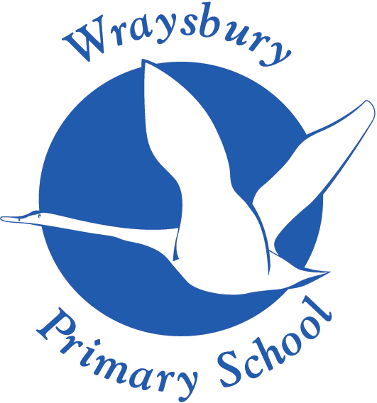

Welley Road
Wraysbury, Staines
TW19 5DJ

Headteacher: Mrs A Fox

Produced by: Music Subject Leader
To be approved by: Music Subject Governor – Awaiting approval
Review date:

Music Policy

Introduction

At Wraysbury Primary School, we aim to help children feel that they are musical, and to develop a life-long love of music. All children are required to participate in musical activities as we value the importance of music for every child in our school. We believe every child is entitled to take part in a range of high quality music experiences, whatever their background, culture or ability to ensure equal opportunities for all.

Intent

We aim to promote children’s enjoyment and understanding of music through:
- Developing the skills, knowledge and understanding that children need in order to become confident performers, composers and listeners.
- Introducing music from all around the world and across generations, teaching children to respect and appreciate the music of all traditions and communities.
- Developing the musical skills of singing, playing tuned and untuned instruments, improvising and composing music, and listening and responding to music.
- Developing an understanding of the history and cultural context of the music that they listen to and learn how music can be written down.
- Help children to develop transferable skills such as team-working, leadership, creative thinking, problem-solving, decision-making, and presentation and performance skills. These skills are vital to children’s development as learners and have a wider application in their general lives outside and beyond school.

The scheme of work that we use - Kapow Primary Music - enables pupils to meet the end of key stage attainment targets outlined in the National Curriculum and the aims of the scheme align with those in the National Curriculum.

Kapow Primary is an Artsmark partner and is able to support us on our Artsmark journey, inspiring our children to create, experience, and participate in great arts and culture.

Implementation

Using Kapow Primary’s Music scheme means that we take a holistic approach to music, in which the individual strands below are woven together to create engaging and enriching learning experiences:
- Performing
- Listening
- Composing
- The history of music
- The inter-related dimensions of music

Each five-lesson unit combines these strands within a cross-curricular topic designed to capture pupils’ imagination and encourage them to explore music enthusiastically. Over the course of the scheme, our children will be taught how to sing fluently and expressively, and play tuned and untuned instruments accurately and with control. They will learn to recognise and name the interrelated dimensions of music – pitch, duration, tempo, timbre, structure, texture and dynamics – and use these expressively in their own improvisations and compositions.

Our lower key stage pupils have the opportunity to develop their expertise in using a tuned instrument which they learn to play for a whole school year. The lessons are carried out by highly qualified music teachers provided by Berkshire Maestros through the In2Music scheme.

Our units of work cover each of the National Curriculum attainment targets as well as each of these strands within it and can be seen on Kapow Primary’s National Curriculum Mapping document. The Progression of Skills and Knowledge document shows the skills that are taught within each year group and how these skills develop year on year to ensure attainment targets are securely met by the end of each key stage.

The scheme follows the spiral curriculum model where previous skills and knowledge are returned to and built upon. Children progress in terms of tackling more complex tasks and doing more simple tasks better, as well as developing understanding and knowledge of the history of music, staff, and other musical notations, as well as the interrelated dimensions of music and more.

In each music lesson, pupils actively participate in musical activities drawn from a range of styles and traditions, developing their musical skills and their understanding of how music works. Lessons incorporate a range of teaching strategies from independent tasks, paired and group work as well as improvisation and teacher-led performances. Lessons are ‘hands-on’ and incorporate movement and dance elements, as well as making cross curricular links with other areas of learning.

Differentiated guidance is available for every lesson to ensure that lessons can be accessed by all pupils and opportunities to stretch pupils’ learning are available when required. Knowledge organisers for each unit support pupils in building a foundation of factual knowledge by encouraging recall of key facts and vocabulary.

Strong subject knowledge is vital for staff to be able to deliver a highly effective and robust music curriculum. Each unit of lessons includes multiple teacher videos to develop subject knowledge and support ongoing CPD, aiding teachers in their own acquisition of musical skills and knowledge. Further CPD opportunities can also be found via webinars with Kapow Primary’s music subject specialists. We use Kapow to support our teachers at Wraysbury Primary so that they feel confident delivering the music curriculum and every effort has been made to ensure that they feel supported to deliver lessons of a high standard that ensure pupil progression.

Our music lessons are timetabled in our school to occur once a week for each year group so that the children can enjoy music regularly with the opportunity to progress on a weekly basic. Every child takes part in a weekly singing assembly.

Peripatetic music tuition is available through outside agencies – currently, piano through Berkshire Maestros and guitar and drums through Rock and Pop.

We value and encourage many opportunities to raise the profile of music with pupils, parents and the community. Every child has the opportunity to take part in a musical production presented to the whole school, parents and members of the community annually. There are many other events where the children enjoy performing music and singing, such as the Harvest Festival (KS1) and the Carol Concert at the local church (KS2). Singing Club perform a range of festive songs at Christmas events around the village of Wraysbury. Opportunities for children to take part in singing events further afield take place annually and venues previously performed at by KS2 children are: The Albert Hall, the Hexagon and the O2.

We are currently in the process of starting our Artsmark journey and are hoping to achieve an Artsmark award by the end of the school year. In our Statement of Commitment, we have many ideas regarding how to raise the profile of music within our school starting with raising our profile online and within the community by sharing our musical achievements via our school website and on social media.

Staff and pupils have access to a wide range of resources to support teaching and learning. We have a wide variety of tuned and untuned percussion instruments which are kept in the music cupboard and are also available for use in classrooms. We continually add to and replace instruments as and when needed and money is allocated to music provision from coordinator budgets. Teachers use the music scheme ‘Kapow Primary’ which is accessed online with a username and password – this is available from the Music Coordinator and is also recorded in the Music file on Teacher Resources. Wraysbury Primary School also has a subscription to ‘Sing up’ – a wide ranging collection of songs which are supported by words on a whiteboard and a variety of tracks to facilitate teaching and then performance of the songs. Sing Up has songs and resources to support every day singing, assemblies, choirs, music lessons and also supports teachers’ professional development with the latest research, advice and updates.

With regard to Health and Safety, children are be taught to handle instruments with care and respect. Instruments are put away after each session and only staff and Upper Junior children are permitted access to the Music Resources area. Appropriate steps are taken to ensure the hygienic use of blowing instruments and all broken or damaged instruments are reported to the Music Leader.

Impact

The impact of the scheme we use at Wraysbury Primary (Kapow Primary Music) can be constantly monitored through both formative and summative assessment opportunities. Each lesson includes guidance to support our teachers in assessing pupils against the learning objectives and at the end of each unit there is often a performance element where teachers can make a summative assessment of pupils’ learning. At the end of each school year, every child will be given an attainment and effort grade as part of their annual report. Knowledge organisers for each unit support pupils by providing a highly visual record of the key learning from the unit, encouraging recall of practical skills, key knowledge and vocabulary.

After the implementation of our scheme of work, pupils should leave Wraysbury Primary School equipped with a range of skills to enable them to succeed in their secondary education and to be able to enjoy and appreciate music throughout their lives.

The expected impact of following the Kapow Primary Music scheme of work is that the children will:
- Be confident performers, composers and listeners and will be able to express themselves musically at and beyond school.
- Show an appreciation and respect for a wide range of musical styles from around the world and will understand how music is influenced by the wider cultural, social, and historical contexts in which it is developed.
- Understand the ways in which music can be written down to support performing and composing activities.
- Demonstrate and articulate an enthusiasm for music and be able to identify their own personal musical preferences.
- Meet the end of key stage expectations outlines in the national curriculum for Music.

