English Policy

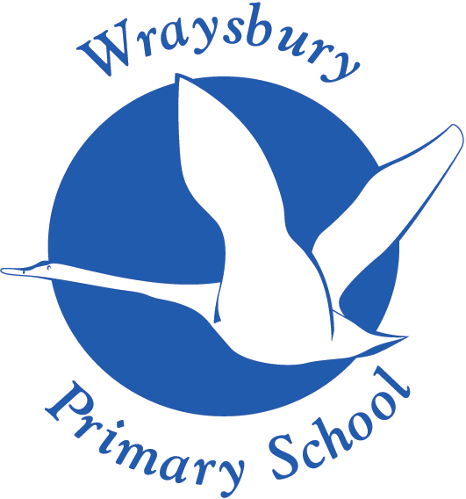

Welley Road
Wraysbury, Staines
TW19 5DJ

Headteacher: Mrs A Fox

Produced by: Kirsty Jenkinson and Emma Wise
Approved by: Teaching and Learning Committee
For approval Summer 2 2025
Review date:

English

‘English has a pre-eminent place in education and in society. A high-quality education in English will teach pupils to speak and write fluently so that they can communicate their ideas and emotions to others and through their reading and listening, others can communicate with them. Through reading in particular, pupils have a chance to develop culturally, emotionally, intellectually, socially and spiritually. Literature, especially, plays a key role in such development. Reading also enables pupils both to acquire knowledge and to build on what they already know. All the skills of language are essential to participating fully as a member of society; pupils, therefore, who do not learn to speak, read and write fluently and confidently are effectively disenfranchised.’ (National Curriculum 2014)

Intent
At Wraysbury Primary School we believe that literacy is a fundamental life skill. Literacy develops children’s ability to listen, speak, read and write for a wide range of purposes. At Wraysbury we believe that children should be enabled to express themselves creatively and imaginatively as they become enthusiastic and critical readers of stories, poetry and drama, as well as of non-fiction and media texts. We want children to gain an understanding of how language works by looking at its patterns, structures and origins and for them to use their knowledge, skills and understanding in speaking and writing across a range of different situations.
Our Aims are:
- To use a diverse range of high-quality core texts that offer a rich context for learning spoken language, reading and writing
- To enable children to develop oracy skills allowing them to speak clearly and audibly, and to take account of their audience;
- To encourage children to listen with concentration, in order to identify the main points of what they have heard;
- To show children how to adapt their speech to a wide range of circumstances and demands;
- To teach children effective communication, both verbal and non-verbal, through a variety of drama activities, including the communication of their ideas, views and feelings.
- To help them become confident, independent fluent readers, through an appropriate focus on word, sentence and text-level knowledge;
- To develop enthusiastic and reflective readers, through contact with challenging and substantial texts;
- To develop a love of reading for all children;
- To foster the enjoyment of writing, and a recognition of its value;
- To encourage accurate and meaningful writing, be it narrative or non- fiction;
- To encourage children to write with an awareness of the audience and purpose of their writing;
- To improve the planning, drafting and editing of their written work, with emphasis on spelling, punctuation and grammar.

Implementation
At Wraysbury Primary School we use a variety of teaching and learning styles in English lessons. Our principal aim is to develop children’s knowledge, skills and understanding of English. English is taught through a variety of approaches including; whole class, group work, investigations, individual tasks and continuous provision. Children have the opportunity to experience a wide range of texts and use a range of resources to support their learning.
Wherever possible, we encourage children to use and apply their learning in other areas of the curriculum.
There are children of differing ability in all classes at Wraysbury Primary School. Teachers have high expectations of all pupils and provide suitable learning opportunities by matching the challenge of the task to the ability of the child.

English is a core subject in the National Curriculum. We use the National Curriculum in England as the basis for implementing the statutory requirements of the programmes of study for English.
We carry out the curriculum planning in English in two phases: a long-term genre overview across the year and detailed PowerPoints.
English lessons and focused reading sessions are delivered from Year 2 to Year 6 each week. In addition, children from Foundation Stage to Year 2 receive focused phonics lessons daily.
Opportunities for cross curricular writing are planned for regularly within each subject, allowing children the chance to transfer and apply their writing skills.
The Early Years Foundation Stage Curriculum is divided into prime and specific areas of learning & development.
‘Communication & Language’ is made up of the following aspects: listening & attention, understanding & speaking. ‘Literacy’ is made up of the following 2 aspects: reading & writing. In EYFS, all aspects of literacy are taught. In our EYFS classes, we use Greg Bottrill’s Drawing Club to form the basis of our English lessons

Reading

Reading is an essential life skill which enables children to access the wider curriculum to its full potential while at school, and take full advantage of their life opportunities as they enter the adult world. We want our children to be able to read easily, fluently and with good understanding while developing the habit of reading widely and often, for both pleasure and information.
Our children will have the ability to read and understand a range of texts allowing them to become independent learners. Furthermore, developing an ability to engage with and respond to literature gives children the opportunity to enrich their lives at a personal level, now and in the future.
To ensure a common understanding of how reading is taught and to ensure that there is consistency in creating a wide range of reading opportunities for children across the school.

Teachers promote and value reading as an enjoyable activity and a life skill. Reading is taught on a daily basis throughout the school. This can take the form of guided, shared or independent reading. Shared reading techniques are used to teach reading in all year groups. In addition, reading skills are taught and practised throughout the curriculum in all subject areas; for example, children may learn comprehension skills when finding information using secondary sources in a History lesson. All teachers are responsible for providing a stimulating reading environment, promoting book ownership and recommending books to pupils.

Phonics
Reading is the key that unlocks the whole curriculum, so the ability to efficiently decode is essential. Children at Wraysbury are taught to read primarily through the Little Wandle Programme. Little Wandle Phonics is a synthetic phonics program designed to help children learn to read and write by breaking down words into their individual sounds and teaching the relationship between these sounds and the letters that represent them. It is a structured and systematic approach to teaching phonics that focuses on the 44 sounds of the English language and their corresponding letter groups.
Writing

We have designed our Writing curriculum so that our learners:
- Develop a life-long enjoyment of writing
- Are able to write fluently so that they can communicate their ideas and emotions to others
- Can develop their vocabulary understanding and use this accurately and in context within their writing.
- Are able to write for a purpose, across a range of different genres, both fiction and non-fiction.
- Understand the spoken word, use expression and participate as a member of society by speaking fluently and articulately.
At Wraysbury we use Drawing Club in EYFS to support the children’s creative approach to writing. In KS1 and 2, we use The Write Stuff. The Write Stuff is based on two guiding principles; teaching sequences that slide between experience days and sentence stacking lessons. With modeling at the heart of them, the sentence stacking lessons are broken into bite- sized chunks and taught under the structural framework of The Writing Rainbow. Teachers prepare children for writing by modelling the ideas, grammar or techniques of writing.
Throughout our school, the children learn vocabulary, grammar, sentence construction and how to plan their writing. Children are taught rich composition skills using adventurous vocabulary, sequencing ideas and events and recounting information in a clear structure to a high standard to suit the purpose and its reader. Children are then taught to draft and redraft their work, making substitutions, developing their ideas and vocabulary with right discussions which then extends their writing into exciting texts. The children have discussions about their writing as if they were authors as well as readers.
Punctuation is also taught within English lessons in order to clarify or enhance meaning. In addition, spelling, grammar and punctuation are also taught discretely to ensure full coverage and understanding.
As they develop, children gain an understanding and appreciation for non-fiction and non-literary genres such as: persuasion argument, explanation, instruction and descriptive writing. They are also taught how to write diaries, autobiographies, biographies and letters. Children are taught to identify and use the most appropriate vocabulary for each text type as well as structural and organisational features such as paragraphing and sub-headings.
Children are also exposed to a range of modern fiction by a diverse range of significant children’s authors, long-established children’s fiction with exciting new texts too. They study high-quality poetry, classic poetry, play scripts, fiction from different cultures and traditions, myths, legends and traditional stories.
Children are set a range of writing tasks throughout the academic year, to ensure a broad range of outcomes are achieved. Each half term, children will write at least 2 pieces of extended writing, based on their core text.

Handwriting and presentation:

At Wraysbury Primary we follow the Letter-join handwriting programme. We ensure the children take pride in their work and from Reception children are taught how to:
● write by holding a pencil properly,
● write from left to right across the page
● form letters in an appropriate size with finger spaces,
● produce clear, well formed, legible writing that is consistent and neat in appearance.
Teachers have high expectations in the presentation of work in all areas of the curriculum. Handwriting is modelled daily and is specifically taught during discrete, weekly sessions.
Children with additional needs have further support to aid fluency in writing. (See Handwriting Policy).

Spelling:

Little Wandle phonics is taught in EYFS and KS1 therefore children learn to spell alongside learning to read using synthetic phonics as the main strategy. Tricky, non-decodable words are also learned in accordance with national guidelines. Spelling Shed is used from Year 2 onwards.

