Year 4 VIPERS Progression Grid

E2: develop positive attitudes to reading and understanding of what they read by identifying how language, structure, and presentation contribute to meaning

E1/S5: listening to and discussing a wide range of fiction, poetry, plays, non-fiction and reference books or textbooks

E2: reading books that are structured in different ways and reading for a range of purposes

V4: using dictionaries to check the meaning of words that they have read

E1/E5: increasing their familiarity with a wide range of books, including fairy stories, myths and legends, and retelling some of these orally

E1: identifying themes and conventions in a wide range of books preparing poems and play scripts to read aloud and to perform, showing understanding through intonation, tone,

volume and action

V2: discussing words and phrases that capture the reader’s interest and imagination

E1/E5: recognising some different forms of poetry [for example, free verse, narrative poetry]

V3/S2: understand what they read, in books they can read independently, by checking that the text makes sense to them, discussing their understanding and V1: explaining the meaning

of words in context

I3: asking questions to improve their understanding of a text

I2/3: drawing inferences such as inferring characters’ feelings, thoughts and motives from their actions, and justifying inferences with evidence predicting what might happen from details

stated and implied

S1: identifying main ideas drawn from more than one paragraph and summarising these

R5: retrieve and record information from non-fiction

E1/2/3: participate in discussion about both books that are read to them and those they can read for themselves, taking turns and listening to what others say

Transcribe the children’s oral responses into written ones and model structures for answering question

Always ask the children to justify their responses to questions – How do you know?

Create comparison grids for different fiction and non-fiction texts

Create semantic grids of texts to help to categorise key information

Write information gained from the text into a different context

Fully develop skimming and scanning techniques – faster finger first – to find particular parts of the text

Relate the text type back to the writing the children have completed

Model how to construct a summary of a text

Jump in – Encourage children to continue the story to the end of the punctuation in a known story

Choral response – Encourage children to read as a group or popcorn ideas to questions asking for deeper responses after the initial response

MyTurnYourTurn – Allow children to discuss in partners or read together

Ask children to become Reading Detectives and search for clues within texts

Model reading strategies – re-reading for clarity and understanding

ooxWord://word/media/image1.jpegooxWord://word/media/image2.jpegooxWord://word/media/image3.jpegooxWord://word/media/image4.jpegooxWord://word/media/image5.jpegooxWord://word/media/image6.jpegooxWord://word/media/image7.jpegooxWord://word/media/image8.jpeg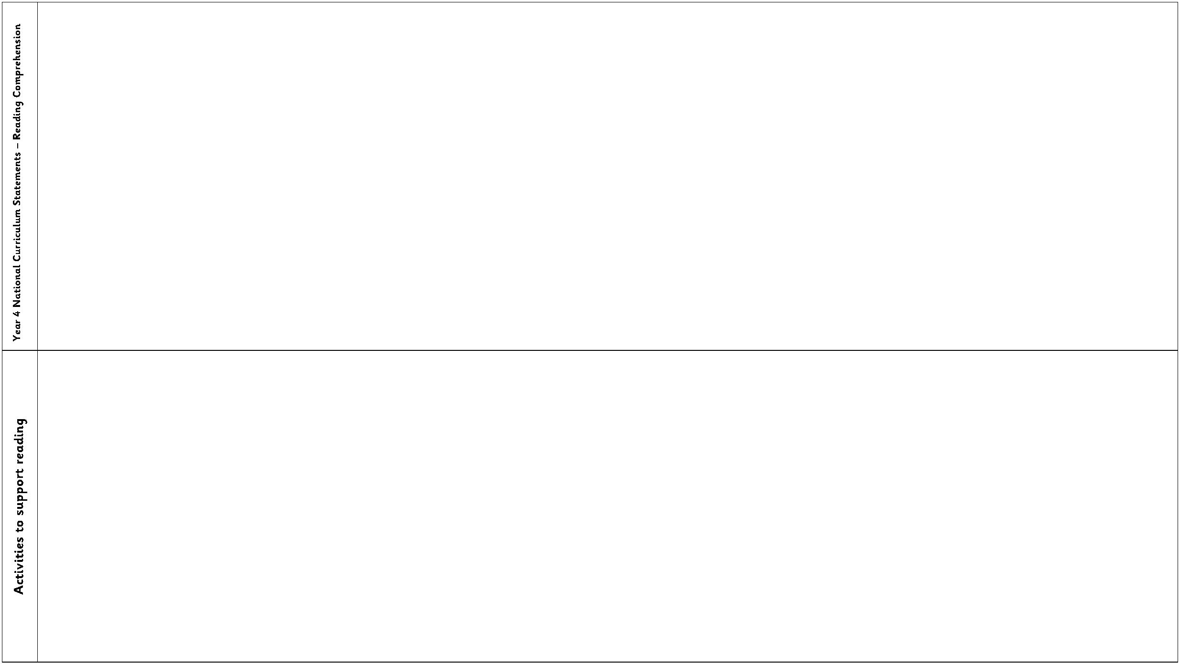

Year 4 VIPERS Progression Grid

Key Reading Skills

Question Stems

V1.

using dictionaries to check the meaning of words that they have read

use a thesaurus to find synonyms

discuss why words have been chosen and the effect these have on the reader

explain how words can capture the interest of the reader

discuss new and unusual vocabulary and clarify the meaning of these

find the meaning of new words using the context of the sentence.

•

Can you find the meaning or a word with a similar meaning in a dictionary or

thesaurus?

V2.

V3.

V4.

V5.

V6.

•

•

•

•

What does this word/phrase/sentence tell you about the character/setting/mood?

By writing..., what effect has the author created?

Do you think they intended to?

What other words/phrases could the author have used here? Why? How has the

author…?

•

Which word is closest in meaning to…?

I1.

ask and answer questions appropriately, including some simple inference questions

based on characters’ feelings, thoughts and motives (I know this because questions)

infer characters’ feelings, thoughts and motives from their stated actions.

consolidate the skill of justifying them using a specific reference point in the text

use more than one piece of evidence to justify their answer

•

•

•

•

•

•

•

•

•

•

•

What do you think.... means?

Why do you think that? Could it be anything else?

I think....; do you agree? Why / why not?

How do you think....?

Can you explain why....?

Can you explain why based on two different pieces of evidence?

What do these words mean and why do you think that the author chose them?

Find and copy a group of words which show that…

What impression of …do you get from this paragraph?

Can you think of another text with a similar theme? How do their plots differ?

Which stories have openings like this? Do you think that this story will develop

the same way?

I2.

I3.

I4.

P1.

P2.

justify predictions using evidence from the text.

use relevant prior knowledge as well as details from the text to form predictions

and to justify them.

P3.

monitor these predictions and compare them with the text as they read on

•

•

•

Why did the author choose this setting? Will that influence the story?

What does this paragraph suggest what will happen next?

Do you think … will happen? Explain your answers with evidence from the text.

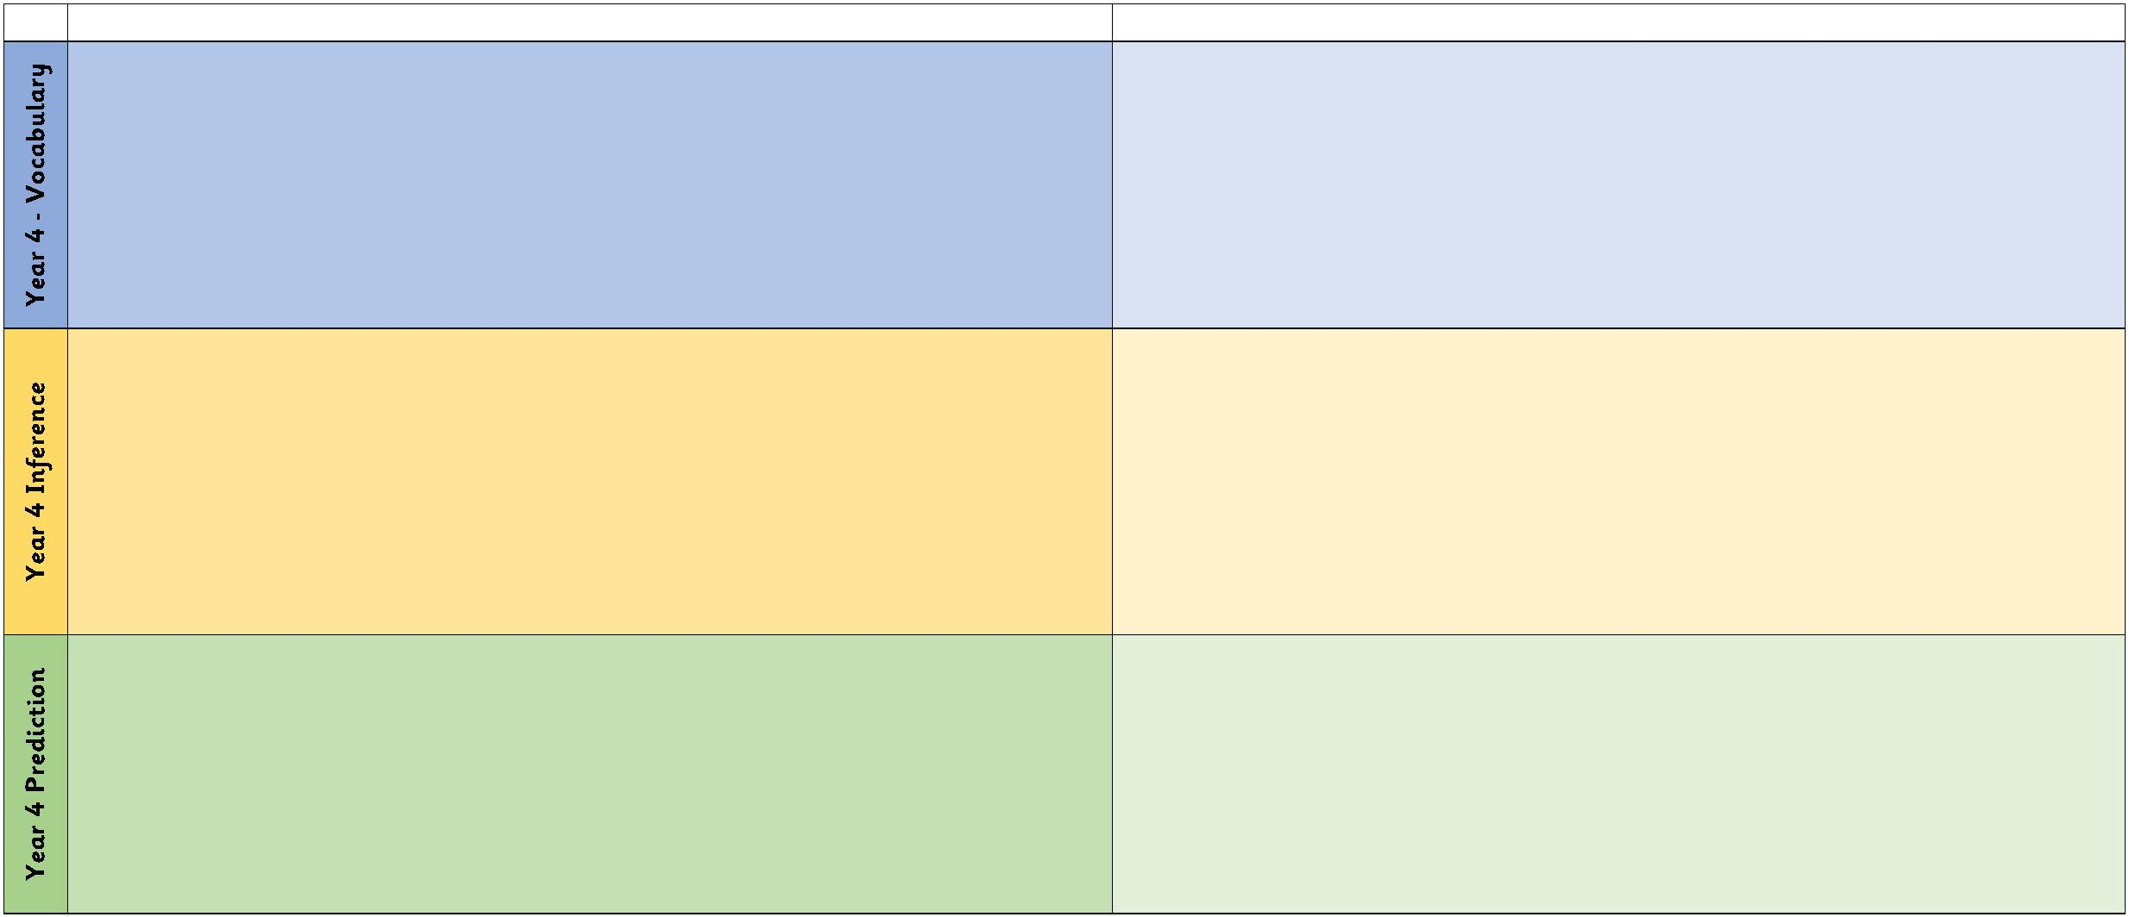

Year 4 VIPERS Progression Grid

E1.

E2.

E3.

discussing words and phrases that capture the reader’s interest and imagination

identifying how language, structure, and presentation contribute to meaning

recognise authorial choices and the purpose of these

•

•

•

•

•

•

•

•

•

•

•

•

•

•

•

•

•

•

•

•

•

•

What is similar/different about two characters? Did the author intend that?

Explain why... did that.

Describe different characters’ reactions to the same event.

Is this as good as...?

Which is better and why?

What can you tell me about how this text is organised?

Why is the text arranged in this way?

What is the purpose of this text and who is the audience?

How does the author engage the reader here?

Which section was the most …? Why?

R1.

R2.

R3.

confidently skim and scan texts to record details,

using relevant quotes to support their answers to questions.

retrieve and record information from a fiction or non-fiction text.

Find the... in this text. Is it anywhere else?

When/where is this story set? How do you know?

Find the part of the story that best describes the setting.

What do you think is happening here? Why?

What might this mean?

Whose perspective is the story told by and how do you know?

How can you use the subheading to help you here?

What is the main point in this paragraph? Is it mentioned anywhere else?

Sum up what has happened so far in X words/seconds or less.

Which is the most important point in these paragraphs? Why?

Do any sections/paragraphs deal with the same themes?

How might I record this to ensure the best possible outcome?

S1.

use skills developed in year 3 in order to write a brief summary of main points,

identifying and using important information.

identifying main ideas drawn from more than one paragraph.

identify themes from a wide range of books

summarise whole paragraphs, chapters or texts

highlight key information and record it in bullet points, diagrams, maps etc

S2.

S3.

S4.

S5.

