Food Policy

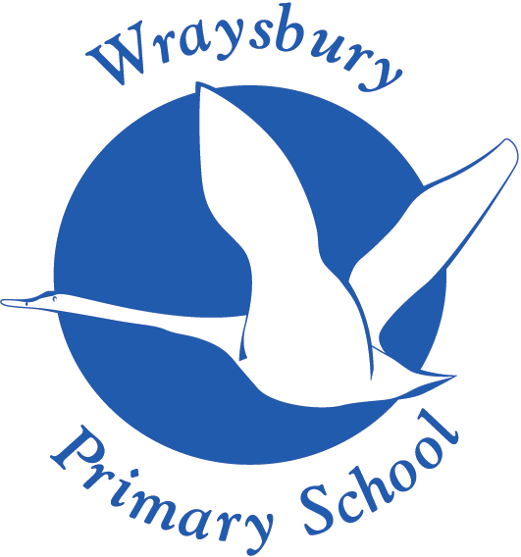

Welley Road
Wraysbury, Staines
TW19 5DJ

Headteacher: Mrs A Fox

Produced by: Jo Allen
Approved by: Awaiting approval Summer 2
Review date:

Food Policy

Intent

At Wraysbury Primary School, we provide a valuable role model to pupils and families with regard to food and healthy eating patterns whilst also encouraging children to make their own choices. Through effective leadership, consistency, the school ethos, and working with both parents and children, all school staff can bring together elements of the school day to create an environment, which supports a healthy lifestyle. We aim to develop the knowledge, skills and capabilities necessary for mental, social, emotional and physical well-being in our children now and for their future. We aim to do this through a broad and balanced curriculum focusing on the development of the whole person. We have with the intent that our children will become, resilient, independent, well-rounded learners that will have the building blocks to become successful, moral adults who live healthy lifestyles.

We will deliver a curriculum that:
- Encourages our children to be self-motivated, independent and resilient individuals who are able to make the best choices for themselves including how to live a healthy lifestyle and understand how to take care of themselves
- Promotes an equal value on their physical and mental well-being and ensures they are prepared for life in modern Britain.
- To ensure that we are giving a consistent message about food and health throughout all areas of school
- Provides pupils with the information they need to make healthy choices
- Promotes health awareness
- Contributes to the healthy and physical development of all members of our school community
- Encourages children to eat a well-balanced, healthy diet
- Encourages children to take responsibility for their own health and to make good choices for themselves

We at Wraysbury Primary School recognise the important connection between a healthy diet and a pupil’s ability to learn effectively and achieve high standards in school. We also recognise the role we can play, as part of a larger community, to promote family health.

Implementation

The curriculum incorporates the statutory requirements of the National Curriculum 2014. Healthy Eating is threaded through the D&T, SMSC and PE curriculum as well as through the whole school ethos.
The teaching, learning and sequencing of the curriculum follows:
- There is a planned, spiral curriculum for healthy eating, cooking and nutrition in all year groups, in line with the National Curriculum.
- The healthy eating curriculum provides a range of opportunities for pupils to have a good understanding, appropriate to their age, of how to eat healthily and maintain a healthy lifestyle.
- Cooking and nutrition is included in the design and technology curriculum and is taught within the appropriate topics.
- Pupils are taught the necessary life skills to help them to live a healthy lifestyle through cooking and nutrition
- In order for teachers to plan engaging activities, up-to-date risk assessments are completed for all food related activities (such as tasting and cooking) which refer to pupil allergies, equipment and food safety. These are shared with all staff.
- Teachers demonstrate good levels of knowledge, confidence and expertise when teaching cooking, nutrition and health eating.
- Staff assess progression of skills and knowledge for food, nutrition and cooking e.g. using the National Curriculum
- Children are offered the opportunity to have share their voice e,g in school council meetings about food and nutrition within school
- School promotes national, local or in-school support and advice for food, nutrition or cooking, such as healthy packed lunches, the Eatwell Guide or Change4Life, via the school website, newsletters or on school notice boards.
- There is provision and support available for pupils or parents/carers in relation to dietary needs, allergies or weight management support.
- The school provides sensitive support for eligible families to claim their Free School Meal entitlement and actively promotes and encourages the take-up of school meals with pupils and parents/carers.
- All catering staff have received relevant, up-to-date training on the School Food Standards and Eatwell Guide. (DfE Healthy Schools Rating Scheme)
- The dining room environment and lunchtime structure are purposefully planned to significantly contribute to positive behaviour.
- There are clearly accessible water points, frequently placed around school, providing fresh, cooled drinking water. All pupils have their own bottles or can easily access cups if needed.
- The school has consistent and effective systems in place to encourage and promote drinking water throughout the day, including during lessons.
- Food at special events, occasions (including birthdays) and on themed days is in line with the whole school food policy, balanced and healthy choices are sometimes available.
- Fundraising events and PTFA, where food is involved, are in line with the whole school food policy, balanced and healthy choices are often available.

Impact

- If children eat better, they feel better, play better and work better.
- Healthier children are more confident and display good behaviour.
- The children will become independent, well-rounded individuals who are able to make their own healthy choices
- Children leave the school with the confidence and skills to make decisions, self-evaluate, make connections and make healthy lifelong choices.

Management and co-ordination

There is an identified member of the Senior Management Team, usually the Headteacher, who oversees all aspects of food within the school. Their role is to ensure the following:

- Establish an effective structure to oversee the development, implementation, monitoring and review of this policy and to encourage a participatory approach to achieving the objectives. Provide an environment that is both physically and socially conducive to the enjoyment of safe, tasty, nutritious, environmentally sustainable food and drink
- Establish a process for reviewing the formal curriculum to ensure information relating to food and nutrition in different lesson areas is consistent and up to date. Ensure the school complies with current National Nutritional Standards for school lunches and other food in school and with the Food in Schools Standards (Feb 2023)
- Ensure that outcomes of the Policy contribute to the completion of the self evaluation process, including the Ofsted SEF and National Healthy School Status.

Monitoring, evaluation and review

The achievement of the objectives and desired outcomes of this policy will be monitored, evaluated and reviewed by senior management and other key stake holders e.g. Governors, Design & Technology Co-ordinator, PSHE Subject Leader, School Council, Pupils, Staff, etc.

Staffing and staff development

All staff, including support and catering staff, need access to professional development and support relating to food, nutrition and basic food hygiene. A range of provision will need to be identified that meets staff needs across a range of roles and responsibilities.
Areas of staff expertise and individual staff development needs will be identified through existing staff development systems. This will be ascertained through systems e.g. staff audit, performance management, etc.

Partnerships

The school values working in partnership with parents/carers and with the wider school community and see it as an essential part of promoting healthy lifestyles. Partnership working will be promoted through initiatives e.g. policy development, home-school contracts, School Councils, working with food and drink suppliers, health professionals, Healthy Schools Staff, the school's contribution to the local community, work with parents, health weeks, enterprise schemes, School Nutrition Action Group, etc.

Equality of opportunity

In accordance with school and Local Authority policy, a commitment to equal opportunities and inclusion will be built into all aspects of food and drink provision.

