Science Policy

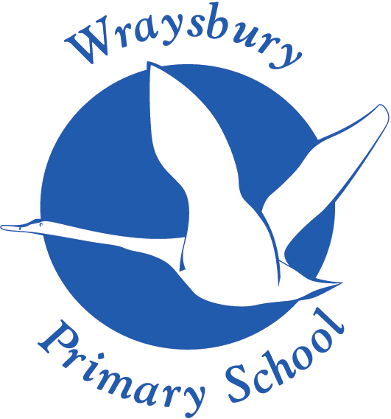
Welley Road
Wraysbury, Staines
TW19 5DJ

Produced by: Rachel Hooker
Approved by: Curiculum and Pupil Welfare Committee May 2025
Review : May 2027

Overview
Children are naturally fascinated by everything in the world around them and want to find out more information to help their understanding. Science underpins all of this learning and is crucial to increase fundamental knowledge. Children learn by playing with things in their world. They pick up clues about what they see, touch, smell, taste and hear in order to makes sense of it all. Eventually they come to conclusions which they match up with all the experiences they have had. Teachers and parents/carers can help children to take a second, careful look at the world. By talking together children can be encouraged to explore and observe so that they can group objects and events and look for similarities and differences. They will need to measure and record the things they have found out in ways that make sense to them so that later they can talk to other people about what they have discovered. They should be encouraged to understand how science can be used to explain what is occurring, predict how things will behave, and analyse causes.
Intent
We live in an increasingly scientific and technological age where children need to acquire the knowledge, skills and understanding to prepare them for life in the 21st century. Through the framework of the National Curriculum 2014, Science at Wraysbury Primary School aims to:
• To stimulate children’s interest and enjoyment in the area of Science.
• Equip children to use themselves as starting points for learning about Science, and to build on their enthusiasm and natural sense of wonder about the world.
• Develop, through practical work, the skills of observation, prediction, investigation, interpretation, communication, questioning and hypothesising, and increased use of precise measurement skills and ICT.
• Encourage and enable pupils to offer their own suggestions, and to be creative in their approach to science, and to gain enjoyment from their scientific work.
• Enable children to develop their skills of co-operation through working with others, and to encourage where possible, ways for children to explore Science in forms which are relevant and meaningful to them.
• Encourage children to collect relevant evidence and to question outcome and to persevere.
• Encourage children to treat the living and non-living environment with respect and sensitivity.
• To encourage children to raise questions and learn how to investigate and explore these using both first-hand experience and secondary sources.
• To help children understand the nature of scientific ideas and to obtain and test the evidence for them.
• To help children recognise and assess risks and hazards to themselves and to others when working with living things and materials and to take action to control them.

At Wraysbury, we believe that every child should be able to access the Science curriculum and teachers need to be responsive to a child’s specific needs. Teachers will use approaches that facilitate engagement, enjoyment and progress with learning in Science for all children. The children are taught that Science is a way of thinking. It is about how we look at the world and questioning what people tell you. It develops a wide set of transferable skills.
By the end of their time at Wraysbury, all children will be able
- To develop their ability to ask questions
- To collect information
- To organize and test ideas
- To solve problems and apply what they have learnt
All these skills are needed to succeed in life.
We understand that the children need to build at least two forms of knowledge.
The first is substantive knowledge - knowledge of the products of science such as models, laws and theories.
The second is disciplinary knowledge - knowledge of the practices of science.
It is important that pupils are taught the disciplinary knowledge across different topics alongside the substantive knowledge so that they develop them in specific science contexts across biology, chemistry and physics.
Implementation
At Wraysbury, we are aware that Science is a core subject and it is vital that teachers make every minute count.
Pupils need to be exposed to science concepts logically so that they can build on the necessary prior learning. Teachers will ensure that this prior learning is highlighted in that particular topic and that connections are made between the different topics.
This allows the knowledge to be embedded and become ‘sticky’.
We use the PLAN knowledge matrices to help specify the key learning that must be covered in each topic based on the National Curriculum Science Programme of Study. Focusing on these allows the teacher to access the substantive knowledge over a period of time while also giving opportunities for them to practice and develop their disciplinary knowledge
We also use the PLAN Progression in Vocabulary document which ensures that each year group is teaching the correct key scientific vocabulary. These words are displayed on our Science Working Walls in each classroom so the children can revisit them at any time during the topic.
Each year group will produce a curriculum map for the particular topic.
Cross curricular links are identified.
To ensure that a broad range of working scientifically skills are taught across the whole school we use the Primary Science Teaching Trust Enquiry Approaches.
- comparative / fair testing
- research
- observation over time
- pattern seeking
- identifying, grouping and classifying
- problem solving
Each class has these displayed and the teacher will highlight which approaches the children are working on during any scientific enquiry. Within these approaches the children are then taught the enquiry skills
- asking questions
- making predictions
- setting up tests
- observing and measuring
- recording data
- interpreting and communicating results
- evaluating
We track the progression by using the PLAN Progression in Working Scientifically Skills document.
In the EYFS, the characteristics of effective learning from the Statutory Framework for the Early Years Foundation Stage are the foundations on which the working scientifically skills build in Key Stage 1. While children are playing and exploring, teachers should be modelling, encouraging and supporting them to do the following:

- show curiosity and ask questions

- make observations using their senses and simple equipment

- make direct comparisons

- use equipment to measure

- record their observations by drawing, taking photographs, using sorting rings or boxes and, in Reception, on simple tick sheets

- use their observations to help them to answer their questions

- talk about what they are doing and have found out

- identify, sort and group.

Assessment
Before each topic is started the teachers will look at the prior learning and discuss this with the previous teachers.
The teacher will then plan to identify the starting point, pinpointing which aspects may need to be revisited or any misconceptions which may have occurred.
During each topic, when children have engaged in sufficient activities to have become secure in the required knowledge the teacher can reflect on the learning (formative assessment). Children who are not secure can be given additional activities or be provided with further opportunities to show that they are secure. This may involve gathering evidence in a different way e.g. verbally in a small group.
Children that are secure can be given enrichment activities to broaden their thinking, while being careful not to stray into the content taught in later years.
At the end of the topic, the teachers will carry out a summative assessment which is then logged on Target Tracker – our Assessment tool.
Resources
We have a wide range of resources available which are monitored by the Subject Leader
Impact
All children will have:
- A wider variety of skills linked to both scientific knowledge and understanding and scientific enquiry/investigative skills
- A richer vocabulary which will enable them to articulate their understanding of taught concepts
- Confidence and the love of learning for all things science
At Wraysbury, teaching science is fun, engaging and high quality. It provides children with the foundations for understanding the world that they can take with them once they complete their primary education.
Children learn the possibilities for careers in Science as of a result of community and enrichment activities.

