**Religious Education**

**Policy**



Welley Road

Wraysbury, Staines

TW19 5DJ

Headteacher: Mrs A Fox

Produced by: **Gemma Clark**

Approved by the RE subject Governor: Awaiting approval

Review date:

**Religious Education**

**Introduction**

Religious Education is unique in the school curriculum in that it is neither core subject nor a foundation subject but the 1988 Education Act states that ‘Religious Education has equal standing in relation to core subjects of the National Curriculum in that it is compulsory for all registered pupils’. Religious Education is taught in our school because it makes:

“a major contribution to the education of children and young people. At its best, it is intellectually challenging and personally enriching. It helps young people develop beliefs and values and promotes the virtues of respect and empathy, which are important in our diverse society. It fosters civilised debate and reasoned argument and helps pupils to understand the place of religion and belief in the modern world”. (RE: realising the potential, Ofsted, 2013).

The RE policy is informed by current national guidance:

RE in English Schools: Non-statutory guidance 2010

RE: Realising the potential Ofsted 2013

A Curriculum Framework for RE in England, REC, 2013

**Intent of Religious Education**

Discovery RE meets the requirements of our locally agreed syllabus and is aligned to the non-statutory guidance described above. By following Discovery RE at Wraysbury Primary School we intend that Religious Education will:

* Adopt an enquiry-based approach as recommended by Ofsted, beginning with the children’s own life experience before moving into learning about and from religion
* Provoke challenging questions about the meaning and purpose of life, beliefs, the self, and issues of right and wrong, commitment and belonging.
* Develop pupils’ knowledge and understanding of Christianity, other principal religions and religious traditions that examine these questions, fostering personal reflection and spiritual development.
* Encourage pupils to explore their own beliefs (religious or non-religious), in the light of what they learn as they examine issues of religious belief and faith and how these impact on personal, institutional and social ethics; and to express their responses.
* Enable pupils to develop their sense of identity and belonging, which helps them flourish within their communities and as citizens in a diverse society.
* Teach pupils to develop respect for others, including people with different faiths and beliefs, and help to challenge prejudice.
* Prompt pupils to consider their responsibilities to themselves and to others, and to explore how they might contribute to their communities and to wider society. It encourages empathy, generosity and compassion.
* Develop a sense of awe, wonder and mystery.
* Nurture children’s own spiritual development.

Religious education should help pupils to:

Learn about religion by:

* Acquiring and developing knowledge and understanding of Christianity and the other principal religions represented in Great Britain
* Developing an understanding of the influence beliefs, values and traditions have on individuals, communities, societies and cultures

Learn from religion by:

* Developing the ability to make reasoned and informed judgements about religious and moral issues with reference to the teachings of the principal religions represented in Great Britain
* Developing a positive attitude towards other people, respecting their right to hold different beliefs and towards living in a society of diverse religions.
* Enhancing their spiritual, moral, social and cultural development by:
* Developing awareness of the fundamental questions of life raised by human experiences, and how religious teachings can relate to them
* Responding to such questions with reference to the teachings and practices of religions and to their understanding and experience
* Reflecting on their own beliefs, values and experiences in the light of their study.

(From The Agreed Syllabus for Religious Education Pan Berkshire 2012-2017 p3)

**Implementation**

Discovery RE covers all areas of RE for the primary phase, Christianity plus one other religion in each group forms the pattern. The grid below shows specific enquiries for each year group.

|  |  |  |  |  |  |  |
| --- | --- | --- | --- | --- | --- | --- |
|  | Autumn 1 | Autumn 2 | Spring 1 | Spring 2 | Summer 1 | Summer 2 |
| Year 1 | Christianity  **Theme:**  Creation Story  **Concept:** God/Creation  **Key Question:**  Does God want Christians to look after the world? | Christianity  **Theme:**  Christmas  **Concept:** Incarnation  **Key Question:**  What gifts might Christians in my town have given Jesus if he had been born here rather than in Bethlehem? | Christianity  **Theme:**  Jesus as a friend  **Concept:** Incarnation  **Key Question:**  Was it always easy for Jesus to show friendship? | Christianity  **Theme:**  Easter - Palm Sunday  **Concept:** Salvation  **Key Question:**  Why was Jesus welcomed  like a king or celebrity by the crowds on Palm Sunday? | Judaism  **Theme:**  Shabbat  **Key Question:**  Is Shabbat important to  Jewish children? | Judaism  **Theme:**  Rosh Hashanah and  Yom Kippur  **Key Question:**  Are Rosh Hashanah and  Yom Kippur important to  Jewish children? |
| Year 2 | Christianity  **Theme:**  What did Jesus teach?  **Key Question:**  Is it possible to be kind to  everyone all of the time? | Christianity  **Theme:**  Christmas - Jesus as gift from God  **Concept:** Incarnation  **Key Question:**  Why do Christians believe  God gave Jesus to the  world? | Islam  **Theme:**  Prayer at home  **Key Question:**  Does praying at regular  intervals help a Muslim in his/her everyday life? | Christianity  **Theme:**  Easter - Resurrection  **Concept:** Salvation  **Key Question:**  How important is it to  Christians that Jesus  came back to life after His  crucifixion? | Islam  **Theme:**  Community and Belonging  **Key Question:**  Does going to a mosque  give Muslims a sense of  belonging? | Islam  **Theme:**  Hajj  **Key Question:**  Does completing Hajj make a person a better Muslim? |
| Year 3 | Hinduism  **Theme:**  Divali  **Key Question:**  Would celebrating Divali at  home and in the community  bring a feeling of belonging to a Hindu child? | Christianity  **Theme:**  Christmas  **Concept:** Incarnation  **Key Question:**  Has Christmas lost its true  meaning? | Christianity  **Theme:**  Jesus’ Miracles  **Concept:** Incarnation  **Key Question:**  Could Jesus heal people? Were these miracles or is there some other explanation? | Christianity  **Theme:**  Easter - Forgiveness  **Concept:** Salvation  **Key Question:**  What is ‘good’ about Good  Friday? | Hinduism  **Theme:**  Hindu Beliefs  **Key Question:**  How can Brahman be  everywhere and in everything? | Hinduism  **Theme:**  Pilgrimage to the River Ganges  **Key Question:**  Would visiting the River Ganges feel special to a non-Hindu? |
| Year 4 | Judaism  **Theme:**  Beliefs and Practices  **Key Question:**  How special is the relationship Jews have with God? | Christianity  **Theme:**  Christmas  **Concept:** Incarnation  **Key Question:**  What is the most significant  part of the nativity story for  Christians today? | Judaism  **Theme:**  Passover  **Key Question:**  How important is it for Jewish people to do what God asks them to do? | Christianity  **Theme:**  Easter  **Concept:** Salvation  **Key Question:**  Is forgiveness always possible for Christians? | Judaism  **Theme:**  Rites of Passage and good  works  **Key Question:**  What is the best way for a Jew to show commitment to God? | Christianity  **Theme:**  Prayer and Worship  **Key Question:**  Do people need to go to church to show they are Christians? |
| Year 5 | Sikhism  **Theme:**  Belief into action  **Key Question:**  How far would a Sikh go for his/her religion? | Christianity  **Theme:**  Christmas  **Concept:** Incarnation  **Key Question:**  Is the Christmas story true? | Sikhism  **Theme:**  Beliefs and moral values  **Key Question:**  Are Sikh stories important  today? | Christianity  **Theme:**  Easter  **Concept:** Salvation  **Key Question:**  How significant is it for  Christians to believe God  intended Jesus to die? | Sikhism  **Theme:**  Prayer and Worship  **Key Question:**  What is the best way for a Sikh to show commitment to God? | Christianity  **Theme:**  Beliefs and Practices  **Key Question:**  What is the best way for a  Christian to show commitment to God? |
| Year 6 | Islam  **Theme:**  Beliefs and Practices  **Key Question:**  What is the best way for a  Muslim to show commitment to God? | Christianity (2nd question)  **Theme:**  Christmas  **Concept:** Incarnation  **Key Question:**  Do Christmas celebrations  and traditions help Christians understand who Jesus was and  why he was born? | Christianity  **Theme:**  Beliefs and Meaning  **Concept:** Salvation  **Key Question:**  Is anything ever eternal? | Christianity  **Theme:**  Easter  **Concept:** Gospel  **Key Question:**  Is Christianity still a strong  religion 2000 years after Jesus was on Earth? | Islam  **Theme:**  Beliefs and moral values  **Key Question:**  Does belief in Akhirah (life after death) help Muslims lead good lives? | |

**Planning and Delivery**

Discovery RE brings together learning about and from religion, questioning and spiritual development in a comprehensive scheme of learning. Teaching strategies are varied and are mindful of preferred learning styles and the need for differentiation. Each enquiry starts from the children’s own life experiences using these as a bridge into the investigation of the religion being studied. Learning is assessed and children have opportunity to express their own thoughts and beliefs and empathise with believers of that religion or belief position. Discovery RE is taught in all year groups in blocks throughout each term.

**Differentiation/SEN**

Discovery RE is written as a universal core curriculum provision for all children. Inclusivity is part of its philosophy. Teachers will tailor each enquiry to meet the needs of children in their classes. To support this differentiation, many enquiries suggest creative learning activities that allow children to choose the media with which they work and give them scope to work to their full potential.

**Assessment and Record Keeping**

Teachers are eager to ensure children are making progress with their learning throughout RE. Therefore, each enquiry has built-in assessment. This task is the formal opportunity for teacher assessment of the children’s knowledge of that religion, depth of critical thinking, and ability to answer the enquiry question. This stand-alone evidence is used in conjunction with other evidence such as records of discussion and annotations from other lessons within the enquiry to assist the teacher with their assessment.

**Links to British Values**

The Discovery scheme of work supports the promotion of British values. Although it does not teach UK law, it teaches children the law of that religion so they can understand what a law might be. The most prominent British value linked throughout the RE curriculum is mutual respect. As with any RE curriculum the main purpose is to promote tolerance of those of different faiths and beliefs. This detailed scheme of work is not planned as individual lesson plans but in the form of medium term planning and because of this many of the values may be covered by the way the teacher/practitioner explains the concepts included and the language used. In Appendix 3 there is a chart representing the most feasible connections that can be made although the teacher may well be able to make further connections to the British values.

**Withdrawal from Religious Education**

Parents may withdraw their children from religious education but must provide written notification to this effect.

Teachers may exercise their right to withdraw from teaching Religious Education.

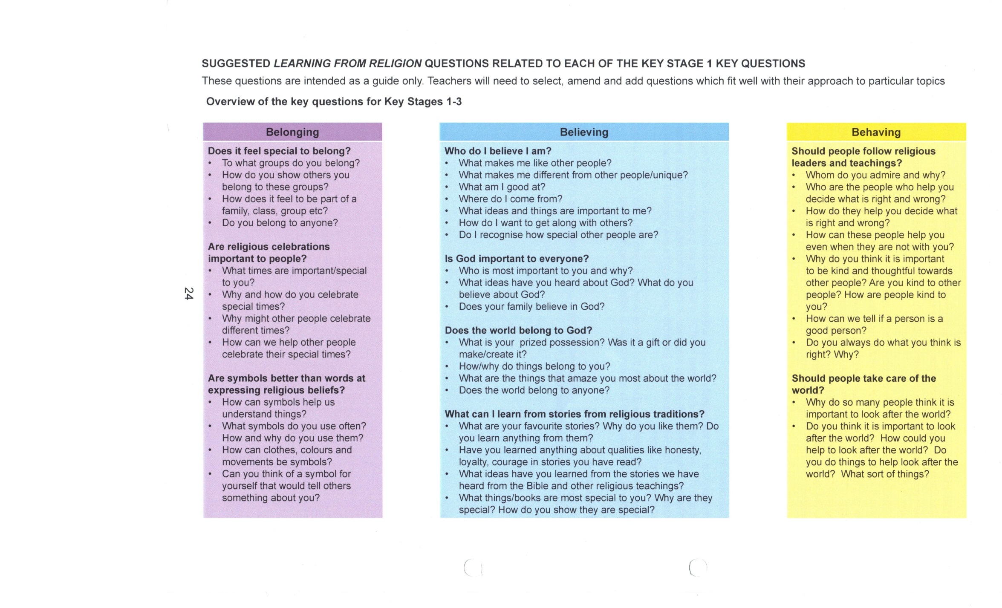Appendix 1

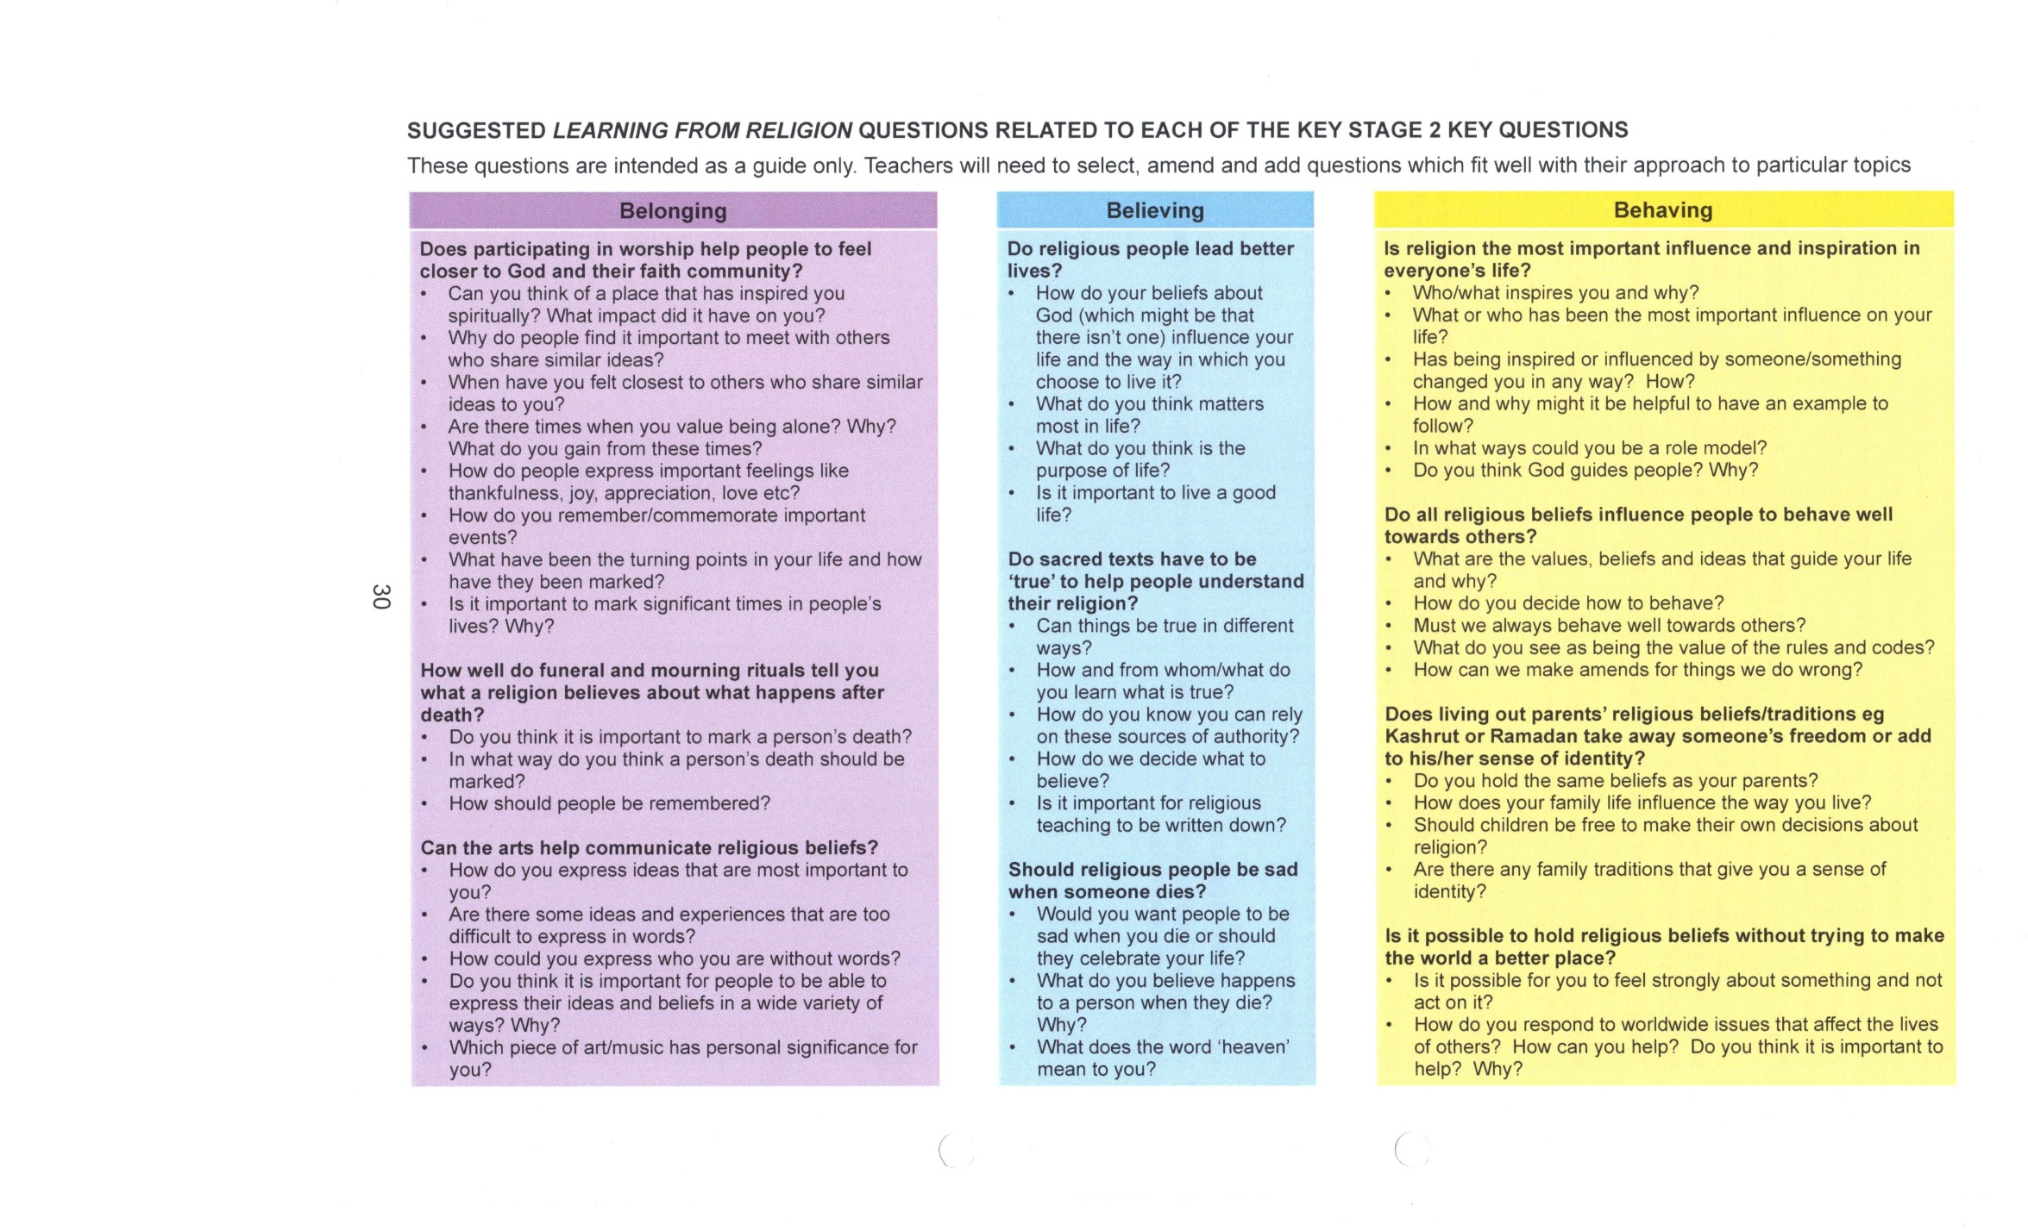Appendix 2