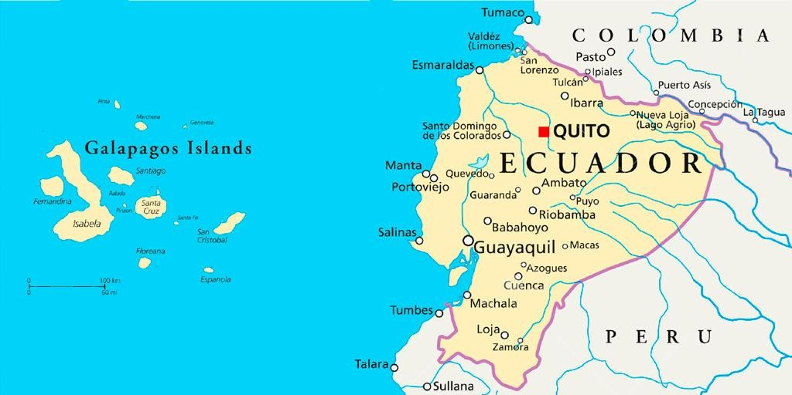
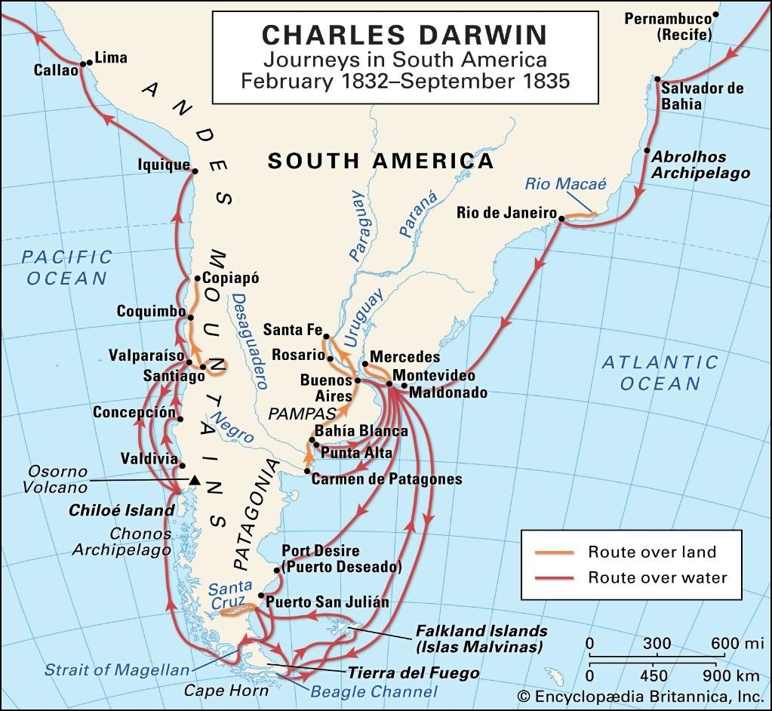
Year 6 Geography Knowledge Organiser: Sail Away!
Ecuador and the Galapagos Islands

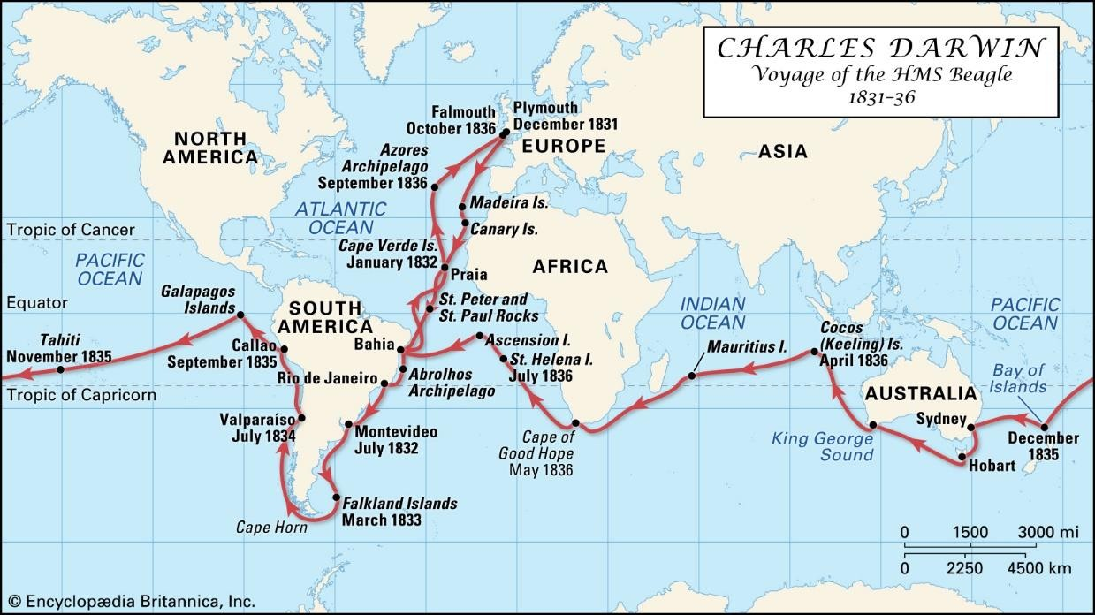
Journeys around the world by Charles Darwin on the HMS Beagle

Eight points of a compass
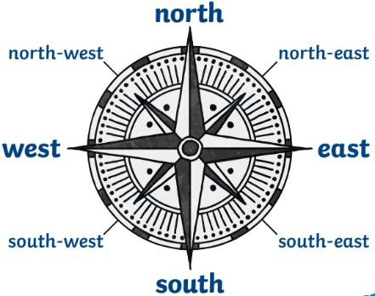

Key  Vocabulary | Definition
Voyage | A long journey involving travel by  sea or air.
HMS Beagle | A Royal Navy ship launched in 1820. Carried Charles Darwin on  its second voyage.
Naturalist | A type of biologist who studies the impacts of living species on each other and the environments  in which they live.
Expedition | A journey with a particular purpose, especially that of  exploration or research.
Discovery | Something found, invented or  uncovered.
Archipelago | A sea or stretch of water having  many islands.
Galapagos Islands | A volcanic archipelago, part of the country of Ecuador and situated  in the Pacific Ocean.
Ecuador | A country in South America, bordered by Colombia on the north, Peru on the east and south, and the Pacific Ocean on the west. Ecuador includes  the Galápagos Islands.
Pacific Ocean | The largest and deepest ocean on  Earth.
Environmental regions | Regions that are based on natural features such as ecosystems,  mountain ranges, soil types.
Physical geography | The study of the earth's surface.  An example of physical  geography is knowledge of earth's oceans and landmasses.

