**Maths Policy**

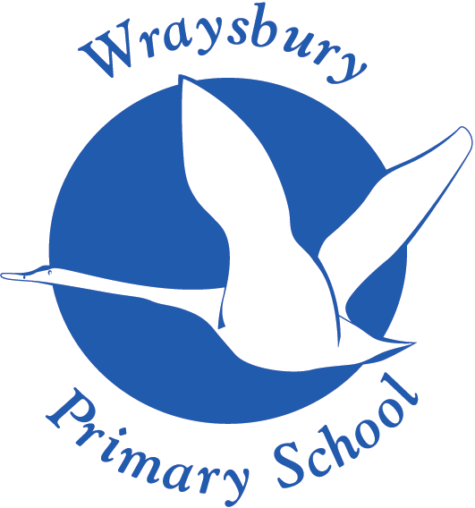

Welley Road

Wraysbury, Staines

TW19 5DJ

Headteacher: Mrs A Fox

Produced by: **Catherine Morrissey**

Approved by the Curriculum and Pupil Welfare Committee: **May 2025**

Next Review date: **May 2027**

**Mathematics**

**Introduction**

‘**Mathematics is a creative and highly inter-connected discipline that has been developed over centuries, providing the solution to some of history’s most intriguing problems. It is essential to everyday life, critical to science, technology and engineering, and necessary for financial literacy and most forms of employment. A high-quality mathematics education therefore provides a foundation for understanding the world, the ability to reason mathematically, an appreciation of the beauty and power of mathematics, and a sense of enjoyment and curiosity about the subject.**’

(National Curriculum, 2014)

**Intent**

At Wraysbury Primary School we want to ignite a sense of curiosity of maths in our children and ensure that they enjoy the subject. Our intent in maths is to ensure that the children become fluent in the fundamentals, can reason mathematically and can solve problems by applying their learning to varied situations with confidence.

We plan and deliver lessons that are creative and engaging and we want our learners to make rich connections across mathematical ideas and concepts, in order to develop competence in mathematics. We want our learners to be confident and able to apply their mathematical knowledge to other aspects of our curriculum. We want learners to understand the importance of understanding mathematics and how it is essential to everyday life, critical to science, technology and engineering and the way it supports us in our classrooms, our home-lives and in the workplace. We use mistakes and misconceptions as an essential part of learning and provide challenges through rich and varied problems. We encourage children to use approaches, which work for them, by equipping them with a range of efficient strategies and ensuring an understanding of them.

Staff are aware and sensitive to the needs of all pupils. We ensure that all pupils have access to the curriculum and utilise a wide range of maths manipulatives. Pupils who are struggling to grasp a concept will have support. Each pupil is catered for with differentiated learning within the scope of each lesson. We incorporate sustained levels of challenge through varied and high-quality activities with a focus on fluency, reasoning and problem solving. Our children are required to explore maths in depth, using mathematical vocabulary to reason and explain their workings. A wide range of mathematical resources are used and pupils are taught to show their workings in a concrete, pictorial or abstract form wherever suitable. They are also taught to explain their choice of methods and develop their mathematical reasoning skills.

**Implementation**

At Wraysbury, we follow a mastery for all approach to our maths curriculum. We use the White Rose Mastery for all approach from Reception through to Year 6 which is aligned with the National Curriculum. We also use a range of planning resources including those provided by NCETM (The National Centre for Excellence in the Teaching of Mathematics) and NRICH (the Norwich, Royal Institution, Cambridge, and Homerton) mathematics outreach project to enrich our children’s maths diet. The calculation policy is used within school to ensure a consistent approach to teaching the four operations. In EYFS, maths is taught with a specific teacher input each day as well as through play-based activities, working with concrete manipulatives, with little emphasis on formal written recordings. These recordings take the form of photographs, observations and problem-solving through play mark making and talking.

**What Maths looks like at Wraysbury Primary School:**

* Maths is taught daily. (45mins at KS1) (1hr at KS2)
* SODA (Start of the day activities) from 08:30-8:50 x2: Early morning maths is taught twice a week, focusing on key skills including place value, the four operations and fractions using PIXL (Partners in Excellence) therapies. Teachers also include maths taught in previous and forthcoming topics– to ensure that mathematical concepts are embedded and frequently revisited.
* Lessons begin with retrieval practice questions; these are to recap previous lesson content to help children build on prior learning.
* Sharing of WALT (We are learning to..), success criteria, modelling and working walls.
* All lessons incorporate the three strands set out by the National Curriculum: Fluency, Reasoning and Problem Solving. Teachers use a variety of interactive teaching methods to deliver the curriculum and achieve set learning objectives. Children are taught through clear modelling and have the opportunity to develop their knowledge and understanding of mathematical concepts through the “I do, We do and You do” approach. Teachers model new learning through Concrete, Pictorial or Abstract methods to guide children through their understanding of mathematical processes
* Teachers will assess children’s work in maths from three aspects (long-term, medium-term and short-term).
* We use short-term assessments to help us adjust our daily plans. These short-term assessments are closely matched to the teaching objectives and give the opportunity for teachers to assess the learning daily and consequently put in place the next step for learning. Teachers use verbal feedback in order to help the children improve in their maths and challenge them to move their learning on. Children mark and respond to their own work in class using a purple pen and teachers look through books at the end of the lesson to see what progress has been made. Children also self-assess their work to show their understanding and where appropriate complete a reflection of how they felt they had done.
* White Rose assessments are administered at the end of each topic and at the end of each term.
* Pre-teaching, where appropriate, is delivered during assembly time by the teachers and TAs to ensure that children are ready for the next lesson.
* Interventions are also used to support children who are not at age related expectations.
* Maths is taught in mixed ability classes across KS1 and KS2.
* Before new topics begin a short quiz/assessment will be delivered to identify children’s starting points.
* One lesson a week is dedicated to fluency and arithmetic skills.
* To improve our understanding of number bonds and times tables, the school uses “Numbots”, “Rockstars” and the “99 Club”. As part of the 99 club, children partake in a weekly speed test based on their number bonds (KS1) or times tables (KS2).
* Where possible links are made with other subjects in the curriculum.
* Home learning is set out by teacher using Numbots and Times tables Rockstars. Children are also given a KIRF (Key Instant Recall Facts) sheet at the beginning of each term to work on at home.
* The maths leader has a clear role and overall responsibility for the progress of all children in maths throughout school. Working with SLT, key data is analysed and regular feedback is provided, to inform on progress and future actions.

**Impact**

Progression is mapped out through the school using long term planning, which shows what topics are covered across each year group. Books show progress for each child over time and in lessons by having work that is pitched at the right level, provides challenge, and picks up on misconceptions. At the end of KS1 and KS2 students will have a love of maths. Pupils will be able to have discussions and “think mathematically” and use skills such as reasoning, conjecturing, generalising and working systematically. Utilising Cultural Capital, our children learn maths as something that is fundamentally useful and can link it to real life situations.

The maths curriculum is monitored and evaluated across the school by:

* Lesson observations and learning walks
* “Book looks” and pupil voice
* Questionnaires with staff, parents and children
* Pupil Progress meetings
* SONAR tracker

In Key Stage 1 and 2 formative assessment is undertaken by teachers daily, through direct observation and questioning, photographs and marking of children's work. Teachers also track children’s progress using SONAR to inform their planning and future teacher.

Summative assessment is undertaken three times a year using PIXL assessments for children in KS1 and KS2. Children also take end of unit tests following the White Rose material. These tests along with the formative assessments help teacher to make a final end of year judgement of the child. They are also used to plug gaps in children’s learning to enable progression.

Following summative assessment testing and SONAR updates, teachers partake in pupil progress meeting with SLT where targets are set and evaluated for all children.

### In Foundation Stage teachers monitor children’s progress using the EYFS curriculum through continual observations. Teachers highlight the Early Learning Goals they achieve throughout the year.

**Evaluation**

This policy is an ongoing working document and will be reviewed regularly to take account of new legislation, new thinking in mathematics education and to update the published material and resources currently in use.