Teaching and Learning Policy

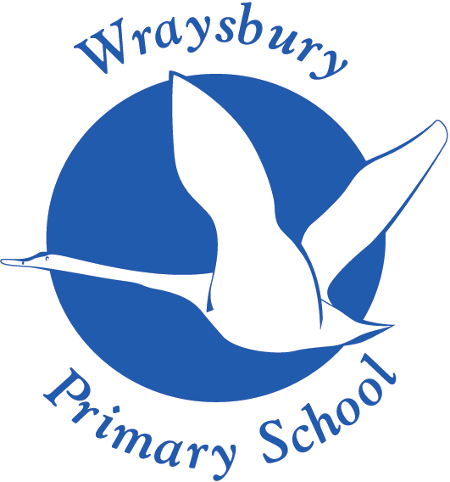

Welley Road
Wraysbury, Staines
TW19 5DJ

Headteacher: Mrs A Fox

Produced by: Myles Gresswell
Approved by Curriculum and Pupil Welfare Committee: June 2023
Next Review date: June 2025

Teaching and Learning Policy

Intent
Our curriculum takes account of the diverse needs of our pupils and the differing needs of each cohort of pupils within the school.

As a school we are acutely aware of the different starting points of our pupils and the different end points. Our pupils come from a variety of different cultural backgrounds and their parents have differing aspirations for their child’s future education.

Our desire is to ensure that every child achieves success and makes as much progress as they can considering their starting point. We strive to meet their varying needs academically, socially and emotionally; sometimes delivering bespoke individual education plans and learning opportunities.

Children from disadvantaged backgrounds, those with social and emotional needs and SEND are nurtured and supported to be the best that they can be. High attaining learners are supported and challenged to achieve a high level in preparation for the next stage of their learning.

Children learn through their whole school experiences. This policy guides what children do, what teachers do, how time is managed, the organisation of the classroom and what the school as an organisation does to create an effective and well-managed learning environment in which the individual needs of each child can be met.

Aims of the Policy
- To improve the standards of achievement for all pupils by improving the quality of learning experiences offered to pupils
- To provide consistency, continuity and balance of practice
- To inform and give guidance to teachers, governors and parents about the characteristic teaching and learning experiences at Wraysbury Primary School
- To share and retain the best features of educational practice
- To offer approaches to teaching and learning which are consistent throughout the school and are adapted to meet the needs of individual pupils.

We believe that children learn best when they:
- Are happy
- Are interested and motivated
- Achieve success and gain approval
- Are given tasks which match their ability
- Clearly understand the task
- Are confident, feel secure and are aware of boundaries
- Are challenged and stimulated.

Educational Provision
The educational provision at Wraysbury Primary School promotes:
- High standards of achievement by all pupils, irrespective of gender, ethnic origin or ability
- The personal development of all pupils in preparing them for future life

At Wraysbury Primary School we aim to ensure that each child receives an education which:
- Is broad and balanced and develops pupils’ knowledge, skills and understanding in:
- all National Curriculum subjects
- Religious Education
- PSHE (including Sex and Relationship Education-SRE)
- for Reception through the Early Years Curriculum
- Provides opportunities to learn through:
- listening
- discussion
- investigation
- observation
- practice
- questioning
- research

We also aim to:
- Provide learning experiences appropriate to each child’s age and ability
- Develop pupils’ confidence through work which builds on their previous knowledge, skills and understanding
- Develop pupils’ self-regulation and meta cognition
- Develop pupils’ interest and enjoyment in their work through a stimulating environment and effective teaching
- Develop pupils’ motivation to succeed through recognition and praise of achievements
- Develop pupils’ personal qualities through spiritual awareness, aesthetic appreciation and gain respect for the world around them
- Promote the importance of healthy living, stress the value of good personal relationships based on mutual respect, empathy and fairness
- Work in partnership with parents and the local community

Implementation
The teacher will:
- Have clear learning objectives which build upon the pupils’ previous knowledge, skills
- Use assessment to inform their teaching
- Organise the learning environment to meet the learning objectives and needs of the pupils
- Aim to stimulate and motivate all pupils in their learning
- Provide pupils with consistently high quality experiences that lead to high levels of achievement
- Set high expectations that challenge all pupils
- Use homework to consolidate or extend learning.

At Wraysbury Primary School we are aware that children’s learning is most effective when:
- They build upon what they have already experienced and know
- They understand what is expected of them
- They have confidence in their own ability and aim to succeed
- The learning environment is well organised, purposeful and calm
- Home and school have a close working partnership.

Groupings of Children
Depending upon the learning intention of an activity, classroom organisation will vary. At times the organisation may include:

Whole Class teaching - is used when the teaching or discussions are appropriate to all the pupils in the class.

Ability groups - allows the teacher and/or the teaching assistant to focus their teaching points on their specific ability

Mixed ability groupings:
- Encourage co operation by working collaboratively
- Develop social skills and build personal relationships
- Enable discussion to develop listening and thinking skills
- Enable children to consolidate ideas by discussing with others.

One to one work - is used when the next step in learning is not appropriate to any other pupils in the class or it is preferable for a pupil to work independently.

Additional tutoring – pre and post teaching sessions take place dependant on the pupils needs. These sessions can be one to one, or in small groups. At certain times in the school year, before and/or after school tutoring sessions take place for specifically targeted pupils.

Curriculum Planning
Long Term Planning
The teaching staff and Governors have agreed policies for all the National Curriculum subjects. For Religious Education the school uses the local diocesan agreed syllabus. Phase teams plan together on a termly basis to ensure coverage of the English and Mathematics objectives across the classes. Curriculum Overviews have been developed which show the whole school curriculum. The RE topics are based on the agreed syllabus as mentioned above. Subject Leaders are responsible for reviewing polices and schemes of work for their subject to ensure that they are appropriate and are being implemented.

Medium Term Planning
Termly plans give more detail on learning objectives, skills and assessment opportunities. These are monitored and updated in each phase and passed on to Subject Leader if required. Some subjects are taught as discrete subjects so that possibly confusing links are not made. Teaching staff produce Topic Maps/Plans for subjects that are cross curricular, these are often History, Geography or Science based. The school also use resources from; Kapow (French, Art and DT and Computing), Jigsaw (PSHE), White Rose (Maths), Little Wandle (Phonics) and VIPERS (Reading).

Weekly Plans
These will be completed by the individual class teacher, or maybe with their parallel teacher. Each plan should clearly show the lesson objectives, outline activities and adult intervention to be undertaken. Differentiation is shown as appropriate, together with opportunities for assessment. Children with Special Education Needs, Pupil Premium and EAL are also identified and planned for. British Values and Spiritual, Moral, Social and Cultural (SMSC) development opportunities will also be noted as appropriate.

Assessment
Assessment is an everyday part of the classroom. Teachers and teaching assistants will make daily observations and will give feedback and mark work throughout the day in order to move the pupils understanding forward. More details are in our Feedback and Marking and Assessment Policies.

Support Staff
Support staff are vital at Wraysbury Primary School in order to add value to the children’s learning. Support staff will work in collaboration with the class teacher. The support staff members’ role will vary across the school depending on the area they are working in. They will work with individual and groups of children in order to help the individual progress.

Impact
Teachers plan stimulating and engaging activities, which build strongly on pupils’ previous learning. As a result, pupils will complete work of an increasingly high quality throughout the school and will therefore make good progress given their starting point.

