**Handwriting**

**Policy**



Welley Road

Wraysbury, Staines

TW19 5DJ

Headteacher: Mrs A Fox

Produced by: **Emma Wise**

Approved by **SMT January 2025**

Review date: **July 2025**

**Handwriting Policy**

**Intent**

Handwriting is a skill which, like reading and spelling, affects written communication across the curriculum. Children must be able to write with ease, speed and legibility. Cursive handwriting teaches pupils to join letters and words as a series of flowing movements and patterns. The development of this fluid style when mastered, allows children to apply their energy into the content of their writing as opposed to the formation of the letters themselves. Handwriting skills are taught regularly and systematically throughout the school.

**Teaching and Learning**

The class teacher is responsible for giving children access to the handwriting curriculum content. English requirements are observed, but wherever possible, handwriting is integrated in all areas of the curriculum. Teachers and all adults in our school aim to adopt a common approach towards handwriting.

**At Wraysbury Primary School our aims in teaching handwriting are:**

* To enable children to write in a consistent, well presented and legible format.
* To have a consistent approach across Foundation Stage, Key Stage 1 and 2 when teaching handwriting.
* To make sure all children know the difference between lower and upper case letters and know how to correctly form lower and upper case letters.
* To adopt a consistent approach towards handwriting by all adults when writing in children’s books, on the whiteboard or on displays / resources.
* To encourage children to develop a sense of pride in their work, enabling them to present work neatly for an audience.
* For each child to know how to position themselves correctly, whether they are right or left handed.
* To be able to write letters and words showing regularity of spacing.
* To ensure the skills taught at Key Stage 1 continue to develop throughout Key Stage 2.

**Implementation**

Children will be taught to:

* hold a pencil correctly, children should be encouraged to use a tripod pencil grip, where the pencil is gripped between the index finger and the thumb. The middle finger is then used to support the underside of the pencil as shown below.
* adopt the correct posture when writing, children should be encouraged to adopt the correct writing position as shown below.
* write from left to right and from top to bottom of the page.
* form regularly sized and shaped letters.
* use regular spacing between letters and words.
* take a pride in their written work and the overall presentation.
* to use the Little Wandle handwriting rhymes (see resources) to help them form lower case and capital letters accurately.
* follow a consistent handwriting style which will be taught consistently throughout the school.

**Scheme of Work**

Pencil Hold, Seating and Paper Position:

* Children should be encouraged to use correct pencil grip in a comfortable manner. If they find this difficult, even after practising with a triangular pencil, try practising the pencil between the index and middle finger as an alternative pencil hold.
* Left handed children should sit to the left of right handed children.
* The angle of the paper depends on the handedness of the pupil. Left handed children should sit with their paper at a slant to the right.
* Very sharp pencils or handwriting pens should be used at all times so that the children can see clearly what the pencil is doing.
* Plain paper is best for the initial stages or writing patterns, progressing to paper which is ruled with lines wider apart. In Key Stages 1 & 2, children will write in a handwriting book or on paper designed specifically for handwriting practice.

**Handwriting in the Foundation Stage**

At Wraysbury Primary School, we realise that the children’s handwriting will only develop when they have increased control over their bodies and a desire to communicate through mark-making.

Before we start to formally teach handwriting, we work on developing the children’s gross and fine motor control and their recognition of pattern.

**Gross Motor Skills**

The children have continuous access to a range of equipment to develop controlled movements of the whole body or limbs and good posture for balancing e.g. balls, bats, bicycles and large scale construction kits.

**Fine Motor Skills**

The children have access to a range of activities which involve small scale movements e.g. peg boards, tweezers, threading and paint brushes etc. In the classroom we have a writing area which is set up daily with resources to promote the children’s fine motor skills. The children are aware that this area is there for them to strengthen their muscles to help them with their writing.

**Recognition of Patterns**

The children have opportunities to make ‘patterns’ in a wide range of areas e.g. ribbons on sticks and obstacle courses to follow. We also encourage the children to form letters in the air and on each other’s backs which reinforces the vocabulary of movement.

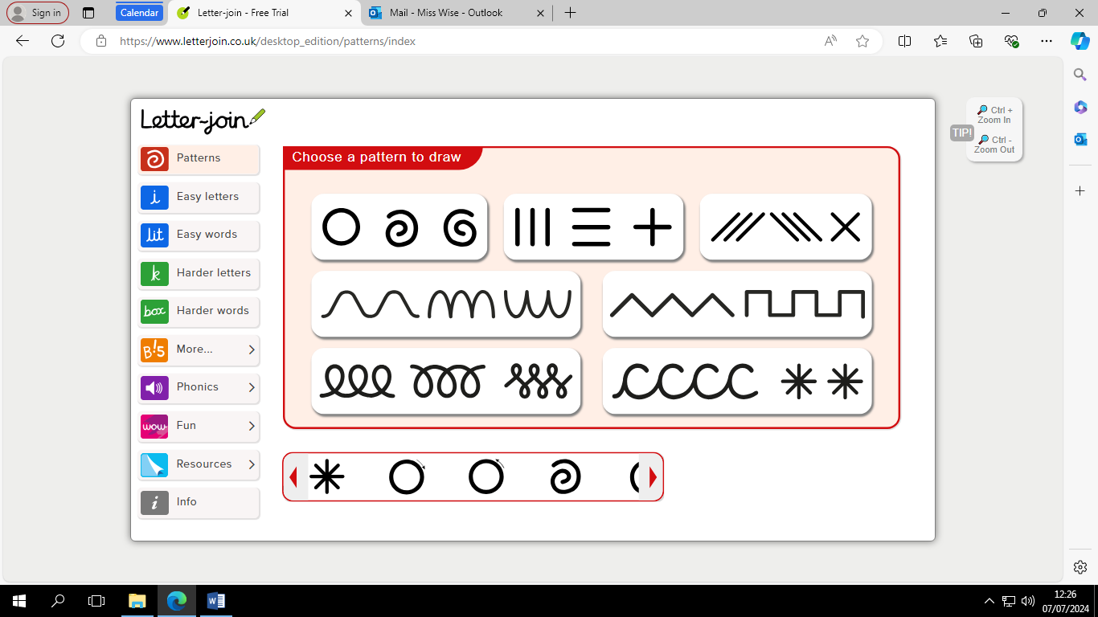

Once we feel that the children are ready, we will start to introduce forming the letters using a pencil. We also teach the children that they need to hold the pencil correctly with a tripod grip so that they start the process of developing a fluent and fast handwriting style.

We appreciate that formal handwriting sheets are not appropriate for this age group.

In order to encourage the children to put pen to paper, writing opportunities are available in all areas of the classrooms, both inside and outside.

Most children are beginning to gain more control over their gross and fine motor skills. Children are given the same opportunities to develop these skills as outlined in the Foundation Stage. Teachers encourage the children to develop a comfortable and correct pencil grip and explain the importance of sitting correctly and positioning themselves for writing.

In small groups, the teacher will encourage the children to trace over patterns between extra wide lines with a pencil. Tracing over the continuous patterns enables the children to develop fluency with their handwriting skills prior to learning the cursive formation of individual letters of the alphabet. Children are encouraged to use a wide range of resources to create these writing patterns such as chalk, paint and paint brushes, felt tip pens and crayons.

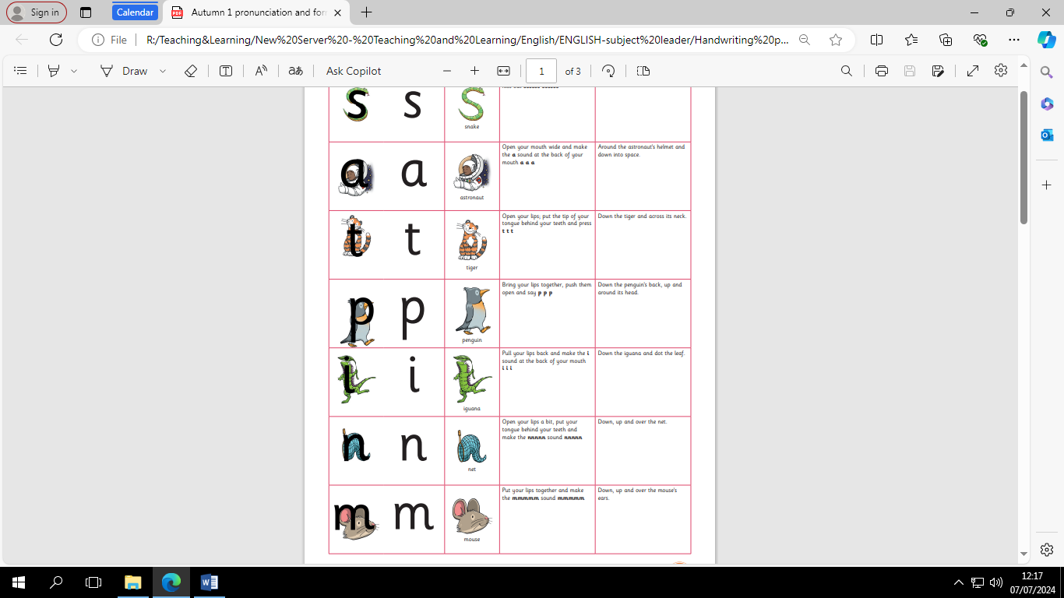

**Year 1**

As the children begin to develop more control over these writing patterns, these will now be formed on lined paper. More formal handwriting sessions begin to start. During these sessions, the children will work on the following letter formation and orientation in the order below regularly.

(See appendix)

**Year 1 and Year 2**

Children need to practise handwriting regularly outside the English lesson in small groups. They will continue to learn the letter formations in the order outlined in Year 1. Alongside this, the children will be taught the correct formation of capital letters which was taught in Year 1.

In Year 2, the children will develop their handwriting, teachers will introduce the children how to join letters together through letter combinations and words. Children are also taught that some letters are best not to be joined. As letter joins are learnt the teacher will encourage children to use these joins in all written work that is produced.

(See appendix)

**Years 3 and 4**

Handwriting in Years 3 and 4 should:

* Consolidate letter formation and joins taught in Years 1 and 2.
* Concentrate on spacing between letters and words.
* Build up handwriting speed and fluency.
* Build on a range of presentation skills.

Children need to practise handwriting regularly outside of English lessons. Handwriting practise will consist of:

* Making links between handwriting, spelling and writing.
* Writing sentences.
* Writing and spelling topic words.
* Redrafting own work to presentation standard.
* Those children in Year 3 upwards will begin to use a pen when appropriate.

**Years 5 and 6**

Handwriting style should be reinforced through all writing activities. Alongside teaching of the spelling objectives teachers will model and practise handwriting. All children are expected to write in pen at this stage. By the end of Year 6, to be expected or above in writing, the children will have to be joining their writing.

(See appendix)

**Provision for left-handed children.**

At least 10% of the population are left-handed, the majority of whom are boys. All teachers are aware of the specific needs of left-handed pupils and make appropriate provision:

• paper should be positioned to the left for right handed pupils and to the right for left handed pupils and slanted to suit the individual in either case.

• pencils should not be held too close to the point as this can interrupt pupils’ line of vision.

• pupils should be positioned so that they can place their paper to their left side.

• left-handed pupils should sit to the left of a right-handed child so that they are not competing for space.

• if following a shape of a letter, left- handed children will have the letter written on the right- hand side of their paper or book, so that they are able to see the letter that they are following.

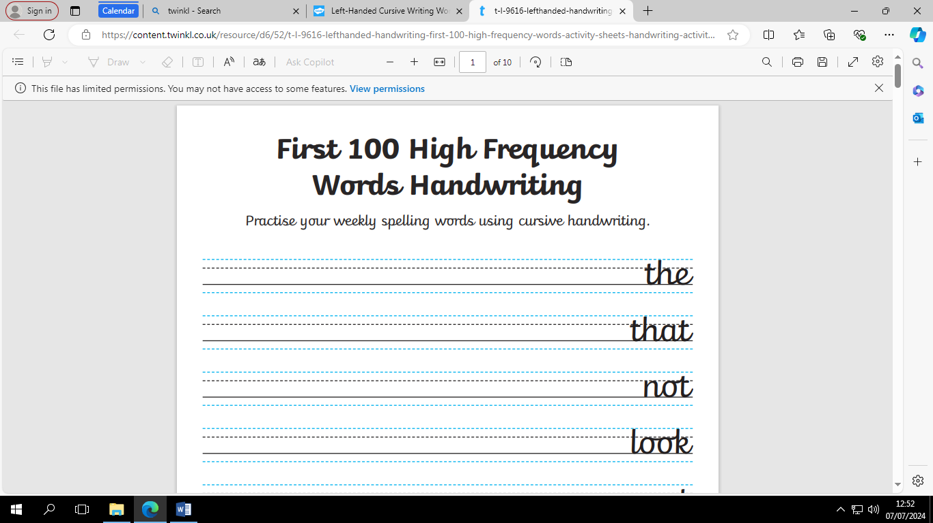

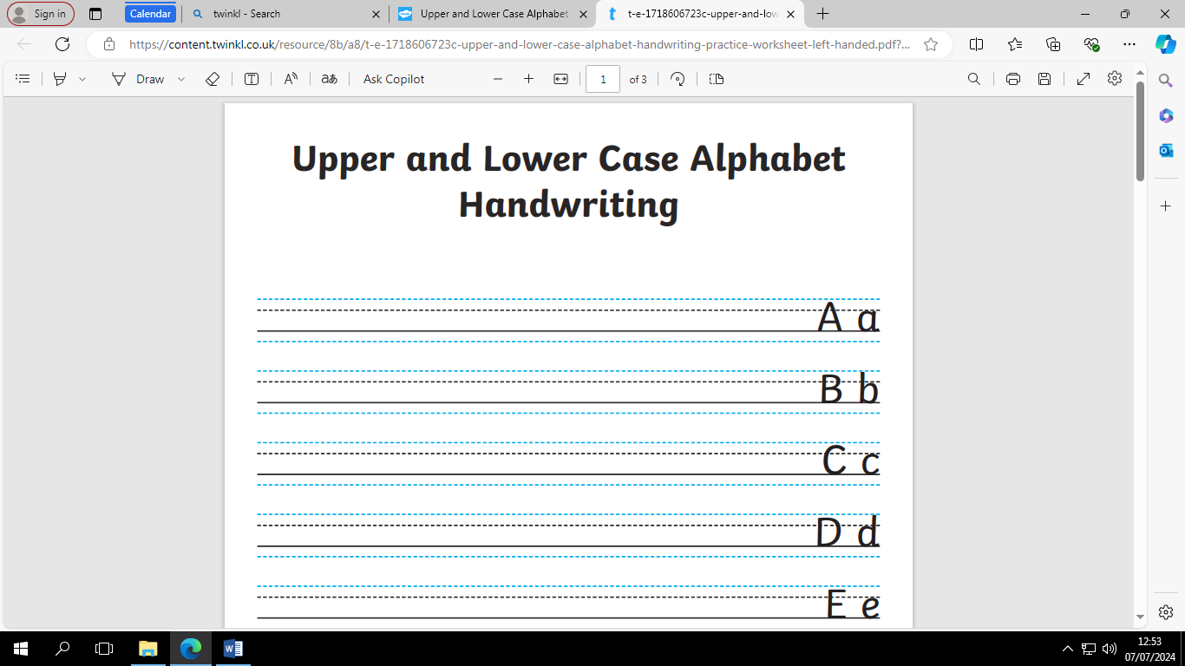

• extra practice with left-to-right exercises may well be necessary before pupils write left-to-right automatically. Teachers are aware of the fact that it is very difficult for left-handed pupils to follow handwriting movements when a right-handed teacher models them. Teachers demonstrate to left-handers on an individual or group basis.

**SEND children**

**Getting ready:**

It’s important to make sure children are ready to write, particularly if they are experiencing handwriting difficulties. Ensure they:

* **sit properly** – ensure that the child sits with their feet on the floor and the table is just above elbow height
* use the right tool – initially, **short pencils** should be used as they are easier to control
* hold the pencil properly – encourage f**unctional tripod grasp** for control and change of direction
* **know how hard to hold the pencil** – writing should be presented with consistent mark-making on the page.
* Understand the consistent pressure for writing (not too light or too hard).

**Grip and Fine Motor Skills:**

* Gradually transition to longer pencils.
* Promote the dynamic tripod grip for efficient writing.
* A good pencil grip reduces hand fatigue.

**In-Hand Manipulation:**

* Strengthen palm muscles through manual dexterity activities.
* Consider using tools like pencil grips to support weak hand muscles.

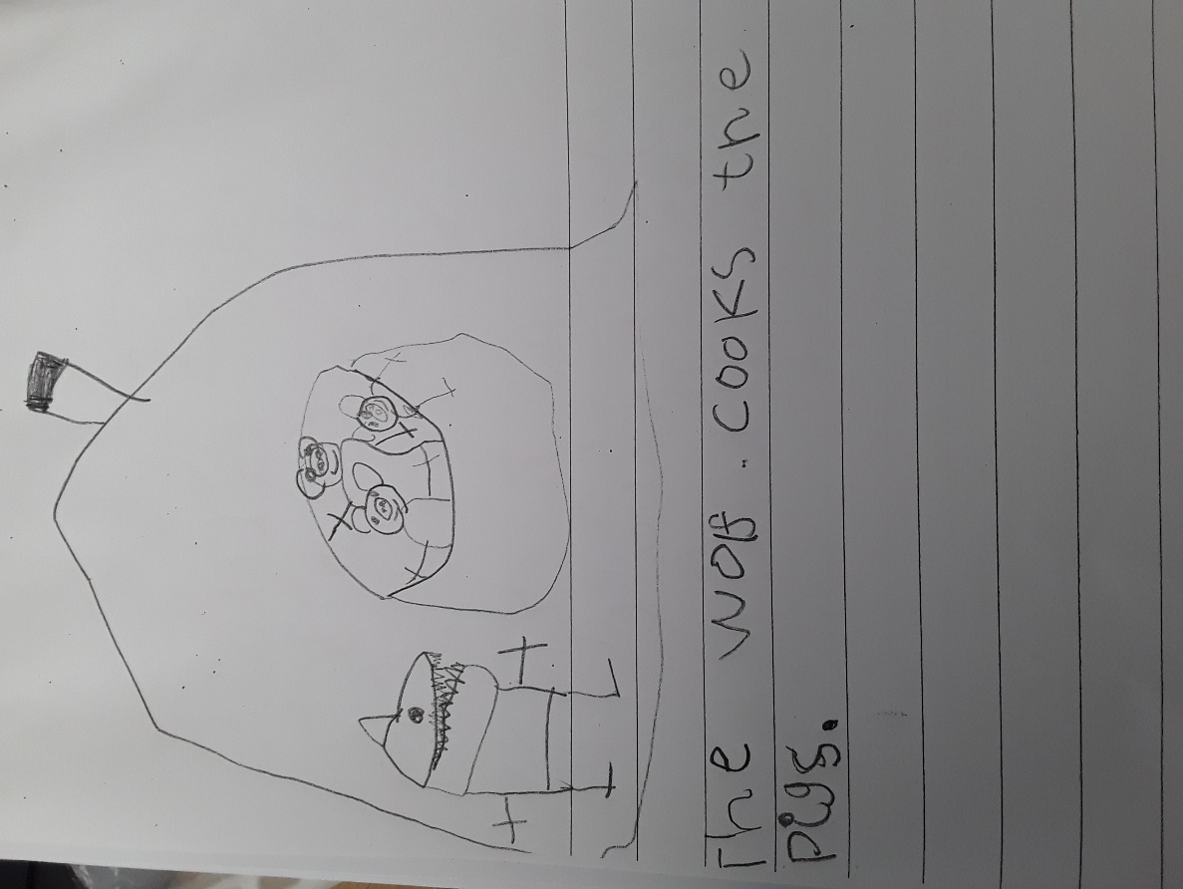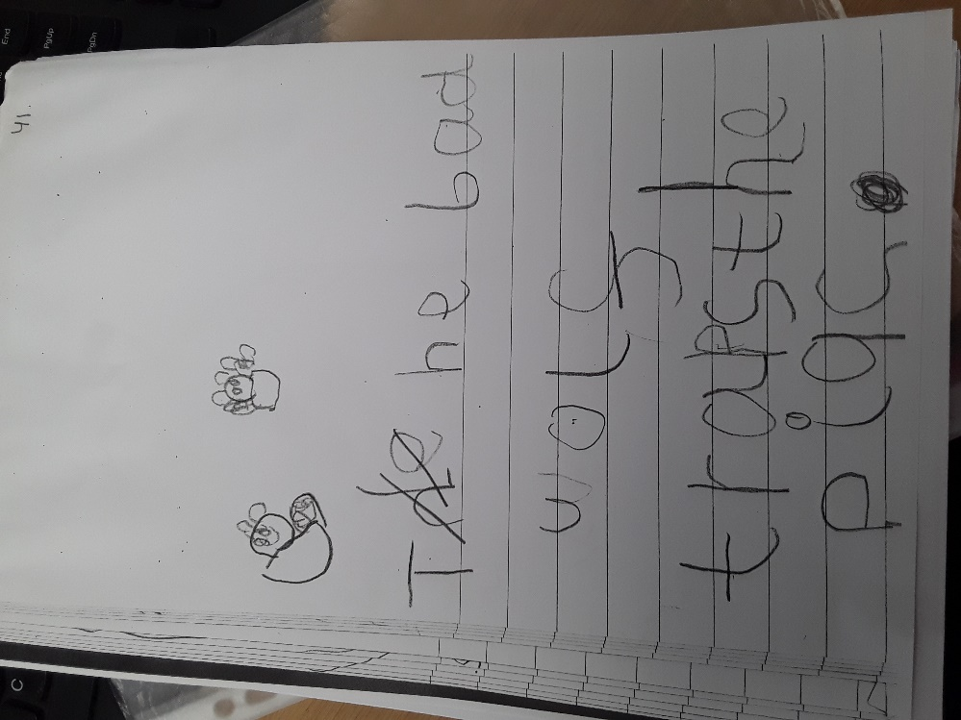Appendices

**EYFS**

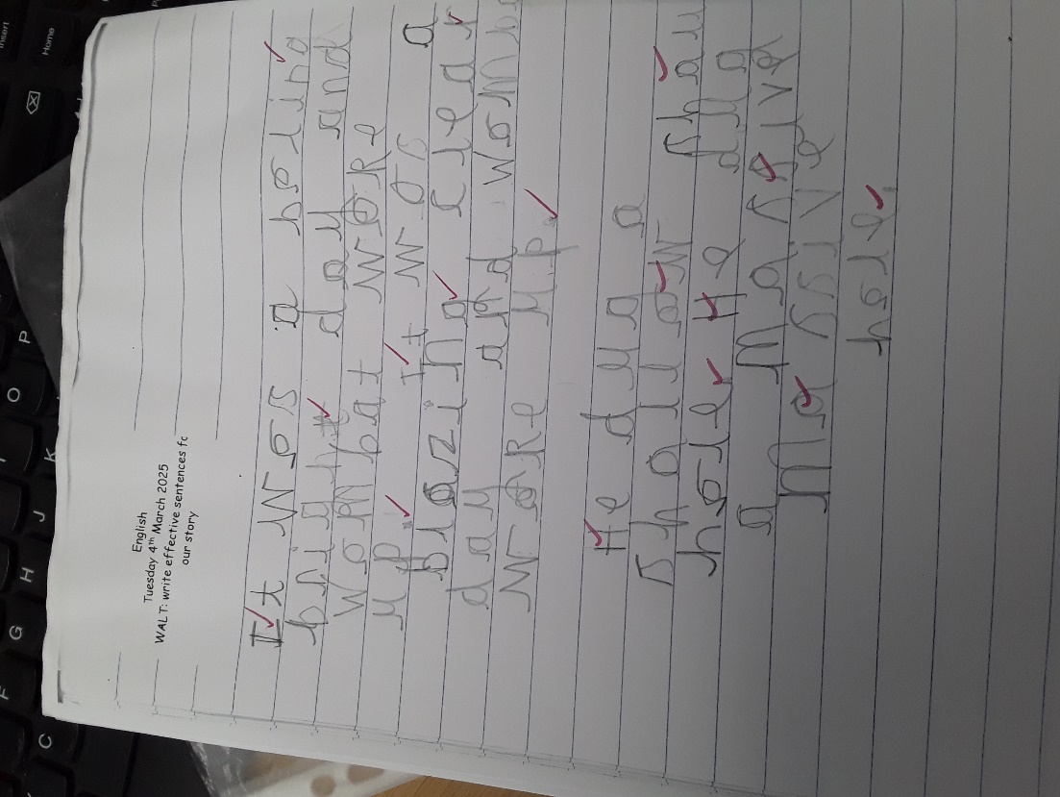**Year 1**

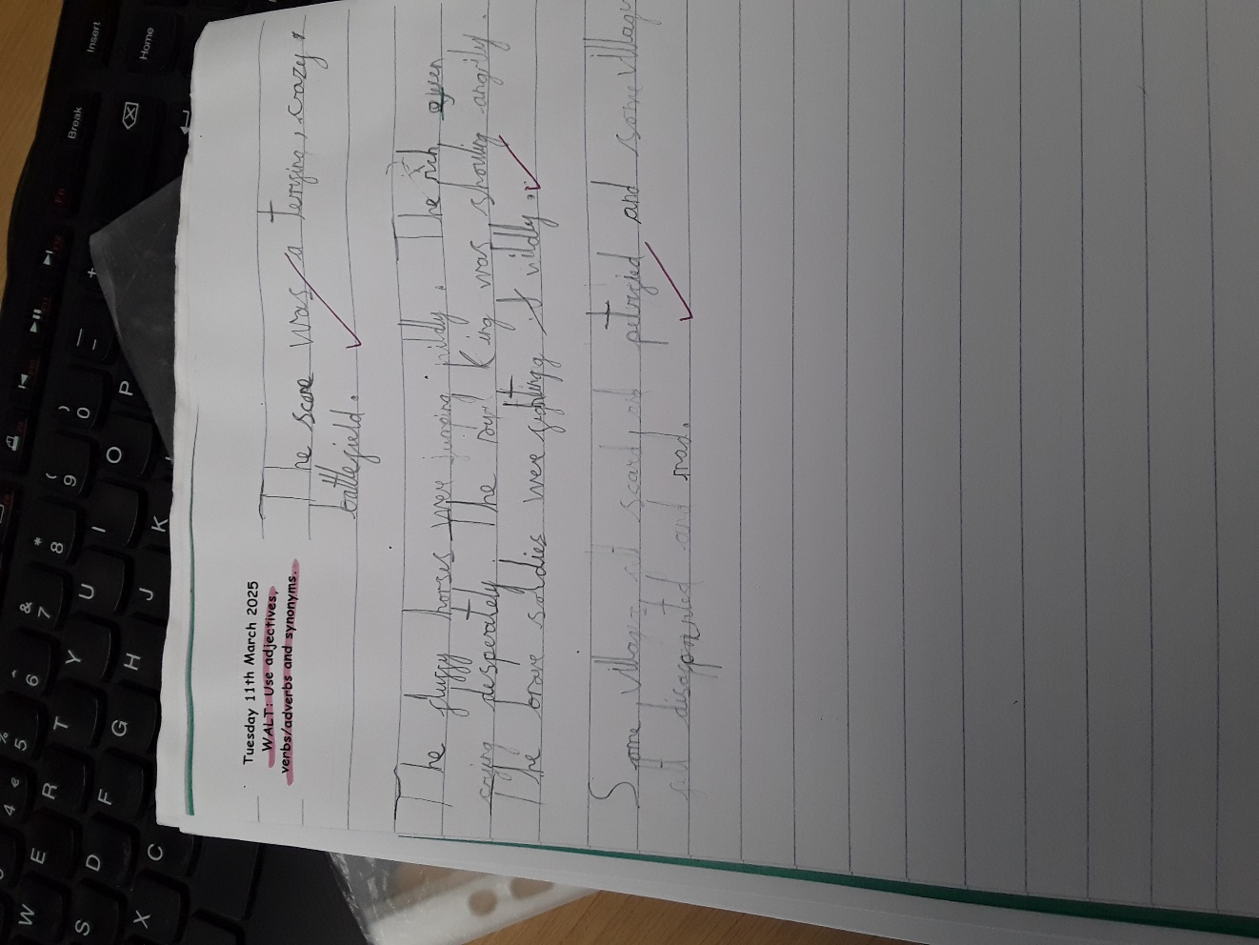

**Year 2**

**Year 3**

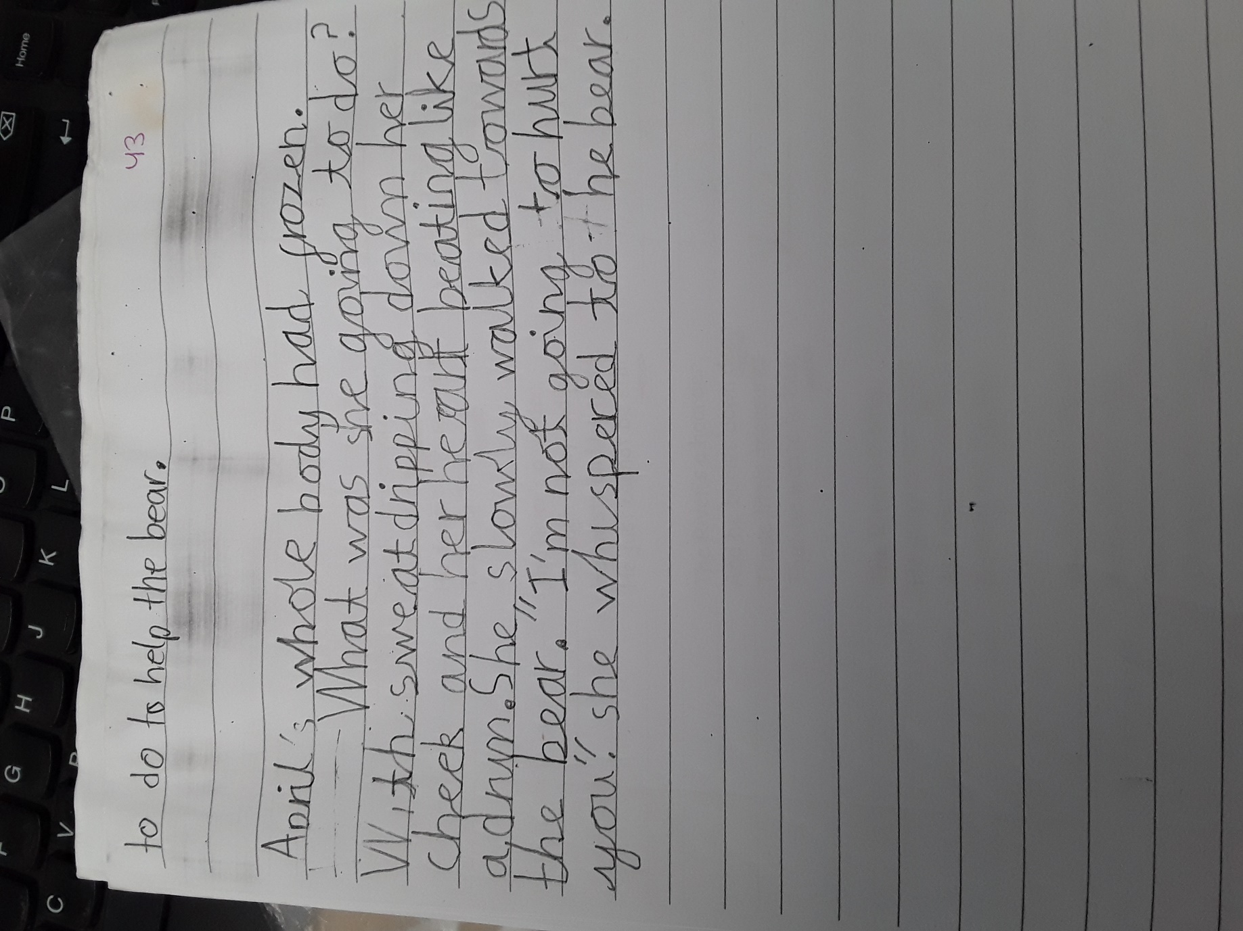

**Year 4**

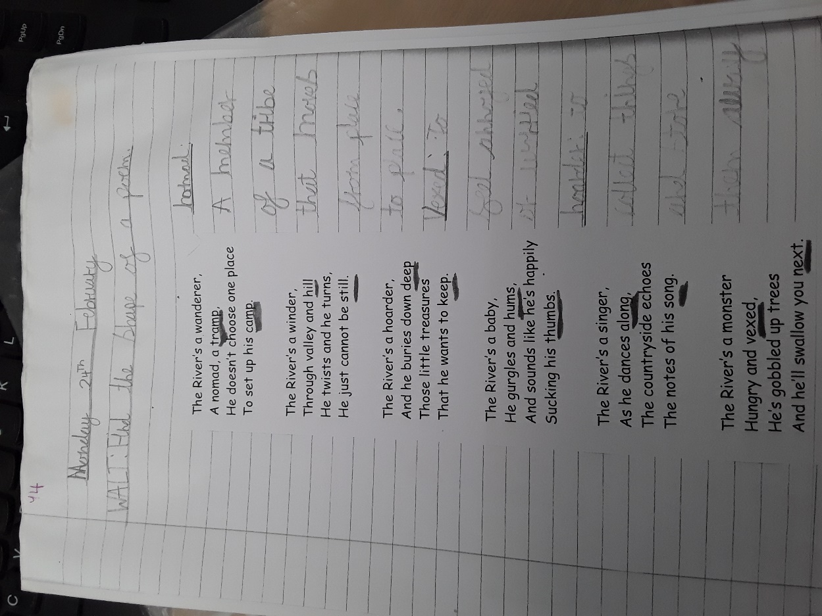

**Year 5**

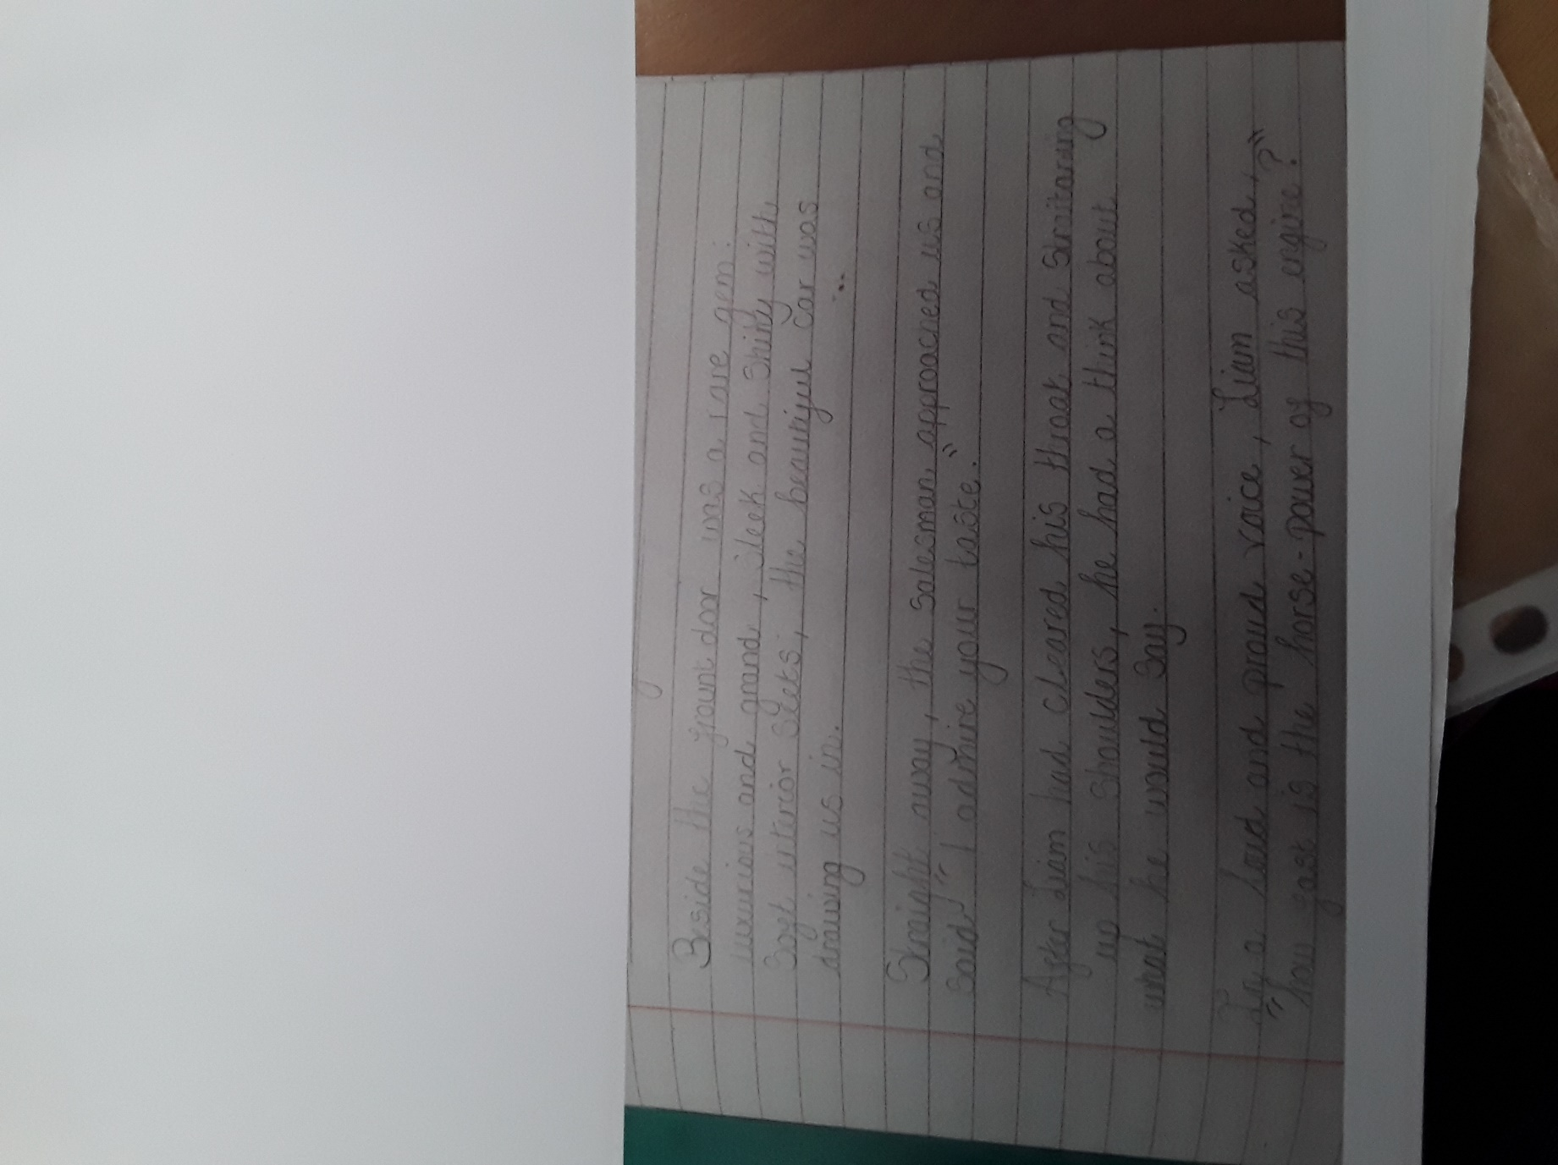

**Year 6**

