Year 4 VIPERS Progression Grid
E2: develop positive attitudes to reading and understanding of what they read by identifying how language, structure, and presentation contribute to meaning
E1/S5: listening to and discussing a wide range of fiction, poetry, plays, non-fiction and reference books or textbooks
E2: reading books that are structured in different ways and reading for a range of purposes
V4: using dictionaries to check the meaning of words that they have read
E1/E5: increasing their familiarity with a wide range of books, including fairy stories, myths and legends, and retelling some of these orally
E1: identifying themes and conventions in a wide range of books preparing poems and play scripts to read aloud and to perform, showing understanding through intonation, tone,
volume and action
V2: discussing words and phrases that capture the reader’s interest and imagination
E1/E5: recognising some different forms of poetry [for example, free verse, narrative poetry]
V3/S2: understand what they read, in books they can read independently, by checking that the text makes sense to them, discussing their understanding and V1: explaining the meaning
of words in context
I3: asking questions to improve their understanding of a text
I2/3: drawing inferences such as inferring characters’ feelings, thoughts and motives from their actions, and justifying inferences with evidence predicting what might happen from details
stated and implied
S1: identifying main ideas drawn from more than one paragraph and summarising these
R5: retrieve and record information from non-fiction
E1/2/3: participate in discussion about both books that are read to them and those they can read for themselves, taking turns and listening to what others say
Transcribe the children’s oral responses into written ones and model structures for answering question
Always ask the children to justify their responses to questions – How do you know?
Create comparison grids for different fiction and non-fiction texts
Create semantic grids of texts to help to categorise key information
Write information gained from the text into a different context
Fully develop skimming and scanning techniques – faster finger first – to find particular parts of the text
Relate the text type back to the writing the children have completed
Model how to construct a summary of a text
Jump in – Encourage children to continue the story to the end of the punctuation in a known story
Choral response – Encourage children to read as a group or popcorn ideas to questions asking for deeper responses after the initial response
MyTurnYourTurn – Allow children to discuss in partners or read together
Ask children to become Reading Detectives and search for clues within texts
Model reading strategies – re-reading for clarity and understanding
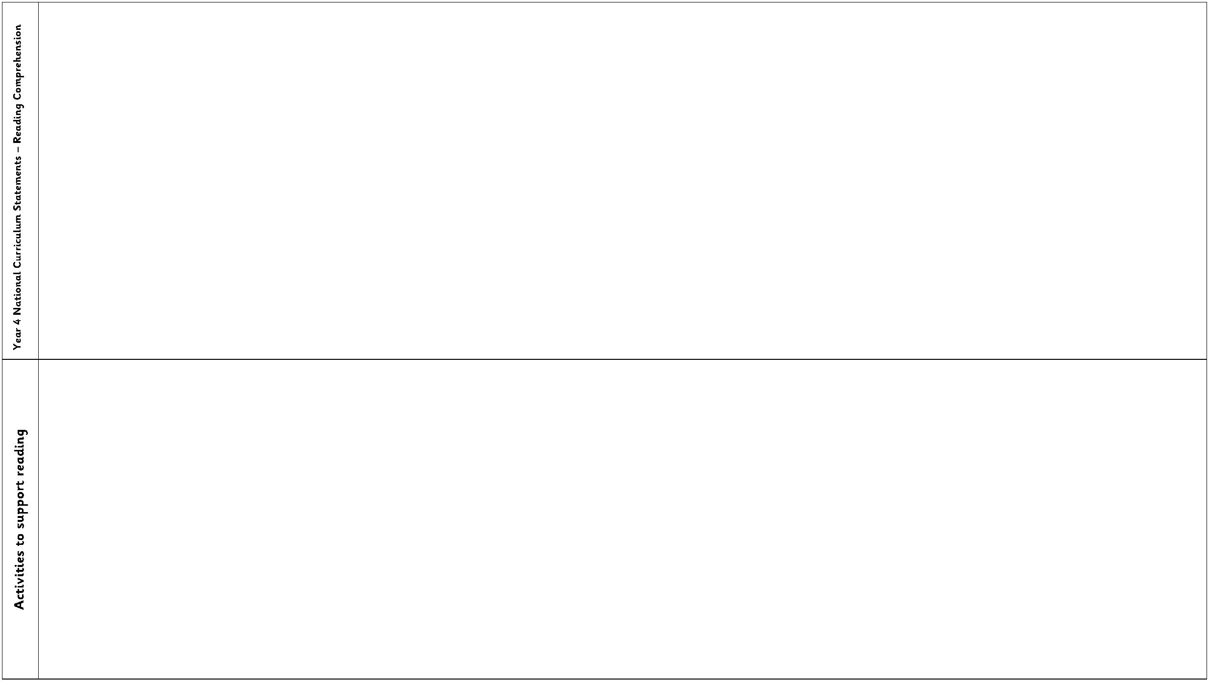

Year 4 VIPERS Progression Grid
Key Reading Skills
Question Stems
V1.
using dictionaries to check the meaning of words that they have read
use a thesaurus to find synonyms
discuss why words have been chosen and the effect these have on the reader
explain how words can capture the interest of the reader
discuss new and unusual vocabulary and clarify the meaning of these
find the meaning of new words using the context of the sentence.
•
Can you find the meaning or a word with a similar meaning in a dictionary or
thesaurus?
V2.
V3.
V4.
V5.
V6.
•
•
•
•
What does this word/phrase/sentence tell you about the character/setting/mood?
By writing..., what effect has the author created?
Do you think they intended to?
What other words/phrases could the author have used here? Why? How has the
author…?
•
Which word is closest in meaning to…?
I1.
ask and answer questions appropriately, including some simple inference questions
based on characters’ feelings, thoughts and motives (I know this because questions)
infer characters’ feelings, thoughts and motives from their stated actions.
consolidate the skill of justifying them using a specific reference point in the text
use more than one piece of evidence to justify their answer
•
•
•
•
•
•
•
•
•
•
•
What do you think.... means?
Why do you think that? Could it be anything else?
I think....; do you agree? Why / why not?
How do you think....?
Can you explain why....?
Can you explain why based on two different pieces of evidence?
What do these words mean and why do you think that the author chose them?
Find and copy a group of words which show that…
What impression of …do you get from this paragraph?
Can you think of another text with a similar theme? How do their plots differ?
Which stories have openings like this? Do you think that this story will develop
the same way?
I2.
I3.
I4.
P1.
P2.
justify predictions using evidence from the text.
use relevant prior knowledge as well as details from the text to form predictions
and to justify them.
P3.
monitor these predictions and compare them with the text as they read on
•
•
•
Why did the author choose this setting? Will that influence the story?
What does this paragraph suggest what will happen next?
Do you think … will happen? Explain your answers with evidence from the text.
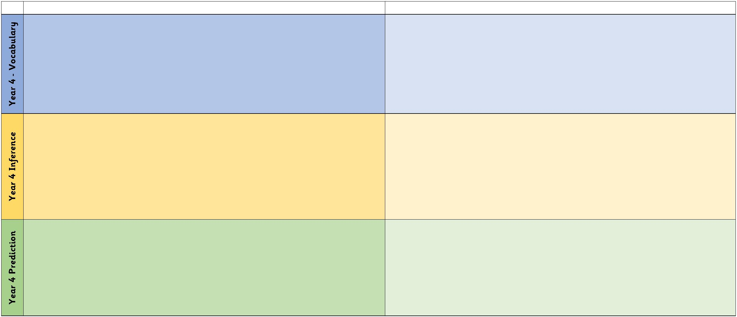

Year 4 VIPERS Progression Grid
E1.
E2.
E3.
discussing words and phrases that capture the reader’s interest and imagination
identifying how language, structure, and presentation contribute to meaning
recognise authorial choices and the purpose of these
•
•
•
•
•
•
•
•
•
•
•
•
•
•
•
•
•
•
•
•
•
•
What is similar/different about two characters? Did the author intend that?
Explain why... did that.
Describe different characters’ reactions to the same event.
Is this as good as...?
Which is better and why?
What can you tell me about how this text is organised?
Why is the text arranged in this way?
What is the purpose of this text and who is the audience?
How does the author engage the reader here?
Which section was the most …? Why?
R1.
R2.
R3.
confidently skim and scan texts to record details,
using relevant quotes to support their answers to questions.
retrieve and record information from a fiction or non-fiction text.
Find the... in this text. Is it anywhere else?
When/where is this story set? How do you know?
Find the part of the story that best describes the setting.
What do you think is happening here? Why?
What might this mean?
Whose perspective is the story told by and how do you know?
How can you use the subheading to help you here?
What is the main point in this paragraph? Is it mentioned anywhere else?
Sum up what has happened so far in X words/seconds or less.
Which is the most important point in these paragraphs? Why?
Do any sections/paragraphs deal with the same themes?
How might I record this to ensure the best possible outcome?
S1.
use skills developed in year 3 in order to write a brief summary of main points,
identifying and using important information.
identifying main ideas drawn from more than one paragraph.
identify themes from a wide range of books
summarise whole paragraphs, chapters or texts
highlight key information and record it in bullet points, diagrams, maps etc
S2.
S3.
S4.
S5.
