Y
Year 3 VIPERS Progression Grid
E2: develop positive attitudes to reading and understanding of what they read by identifying how language, structure, and presentation contribute to meaning
E1/S5: listening to and discussing a wide range of fiction, poetry, plays, non-fiction and reference books or textbooks
E2: reading books that are structured in different ways and reading for a range of purposes
V4: using dictionaries to check the meaning of words that they have read
E1/E5: increasing their familiarity with a wide range of books, including fairy stories, myths and legends, and retelling some of these orally
E1: identifying themes and conventions in a wide range of books preparing poems and play scripts to read aloud and to perform, showing understanding through
intonation, tone, volume and action
V2: discussing words and phrases that capture the reader’s interest and imagination
E1/E5: recognising some different forms of poetry [for example, free verse, narrative poetry]
V3/S2: understand what they read, in books they can read independently, by checking that the text makes sense to them, discussing their understanding and V1:
explaining the meaning of words in context
I3: asking questions to improve their understanding of a text
I2/3: drawing inferences such as inferring characters’ feelings, thoughts and motives from their actions, and justifying inferences with evidence predicting what might
happen from details stated and implied
S1: identifying main ideas drawn from more than one paragraph and summarising these
R5: retrieve and record information from non-fiction
E1/2/3: participate in discussion about both books that are read to them and those they can read for themselves, taking turns and listening to what others say
Transcribe the children’s oral responses into written ones and model structures for answering question
Always ask the children to explain their responses to questions – How do you know?
Model creating story maps of events and speech bubbles to demonstrate characters actions, thoughts and feelings
Relate the text type back to the writing the children have completed
Model how to construct a summary of a text
Jump in – Encourage children to continue the story to the end of the punctuation in a known story
Choral response – Encourage children to read as a group or popcorn ideas to questions asking for deeper responses after the initial response
MyTurnYourTurn – Allow children to discuss in partners or read together
Ask children to become Reading Detectives and search for clues within texts
Model reading strategies – re-reading for clarity and understanding
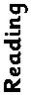
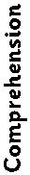
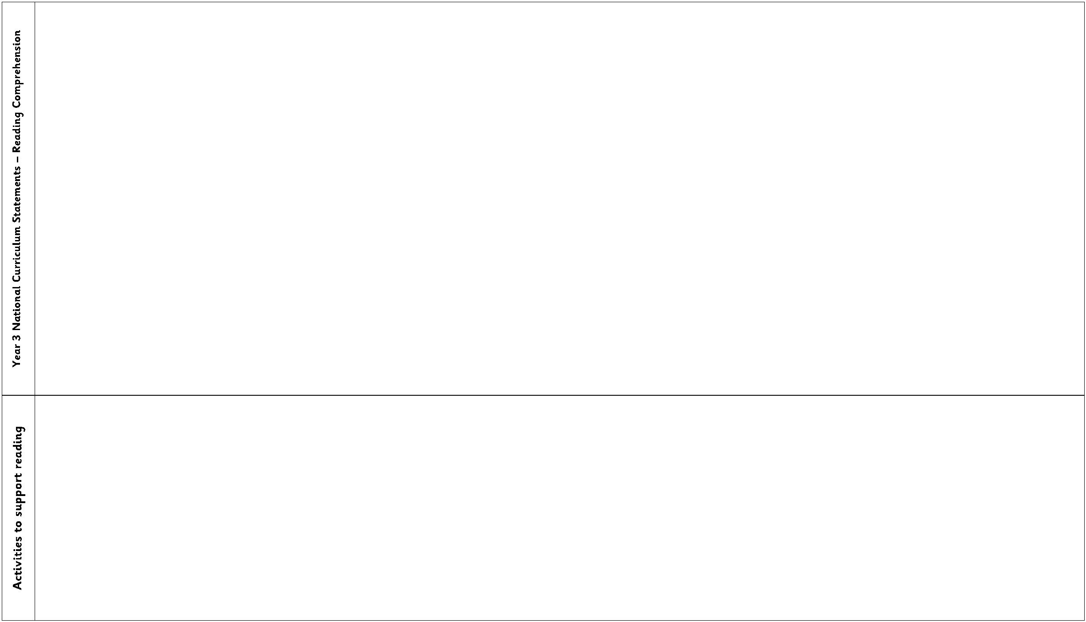

Year 3 VIPERS Progression Grid
Key Reading Skills
Question Stems
V1.
use dictionaries to check the meaning of words that they have read
discuss words that capture the readers interest or imagination
identify how language choices help build meaning
•
What does this word/phrase/sentence tell you about the
character/setting/mood?
Can you find this word in the dictionary?
By writing in this way, what effect has the author created?
What other words/phrases could the author have used here?
How has the author made you feel by writing...?
Which word tells you that…?
V2.
V3.
V4.
•
•
•
•
•
•
find the meaning of new words using substitution within a sentence.
Find and highlight the word that is closest in meaning to…?
I1.
children can infer characters’ feelings, thoughts and motives from their stated
actions.
justify inferences by referencing a specific point in the text.
ask and answer questions appropriately, including some simple inference questions
based on characters’ feelings, thoughts and motives.
make inferences about actions or events
•
•
•
•
•
•
•
•
•
•
•
•
•
•
•
•
What do you think.... means?
Why do you think that?
Why do you think...?
How do you think....?
I2.
I3.
Can you explain why....?
I4.
What do these words mean and why do you think that the author chose them?
Find and copy a group of words which show…?
How does the description of … show that they are…?
Who is telling the story?
Why has the character done this at this time?
Can you think of another story with a similar theme?
Which stories have openings like this?
Do you think that this story will develop the same way?
Why did the author choose this setting? Will that influence the story?
What happened before this and what do you think will happen after?
Do you think the setting will have an impact on plot moving forward?
P1.
P2.
P3.
justify predictions using evidence from the text.
use relevant prior knowledge to make predictions and justify them.
use details from the text to form further predictions.
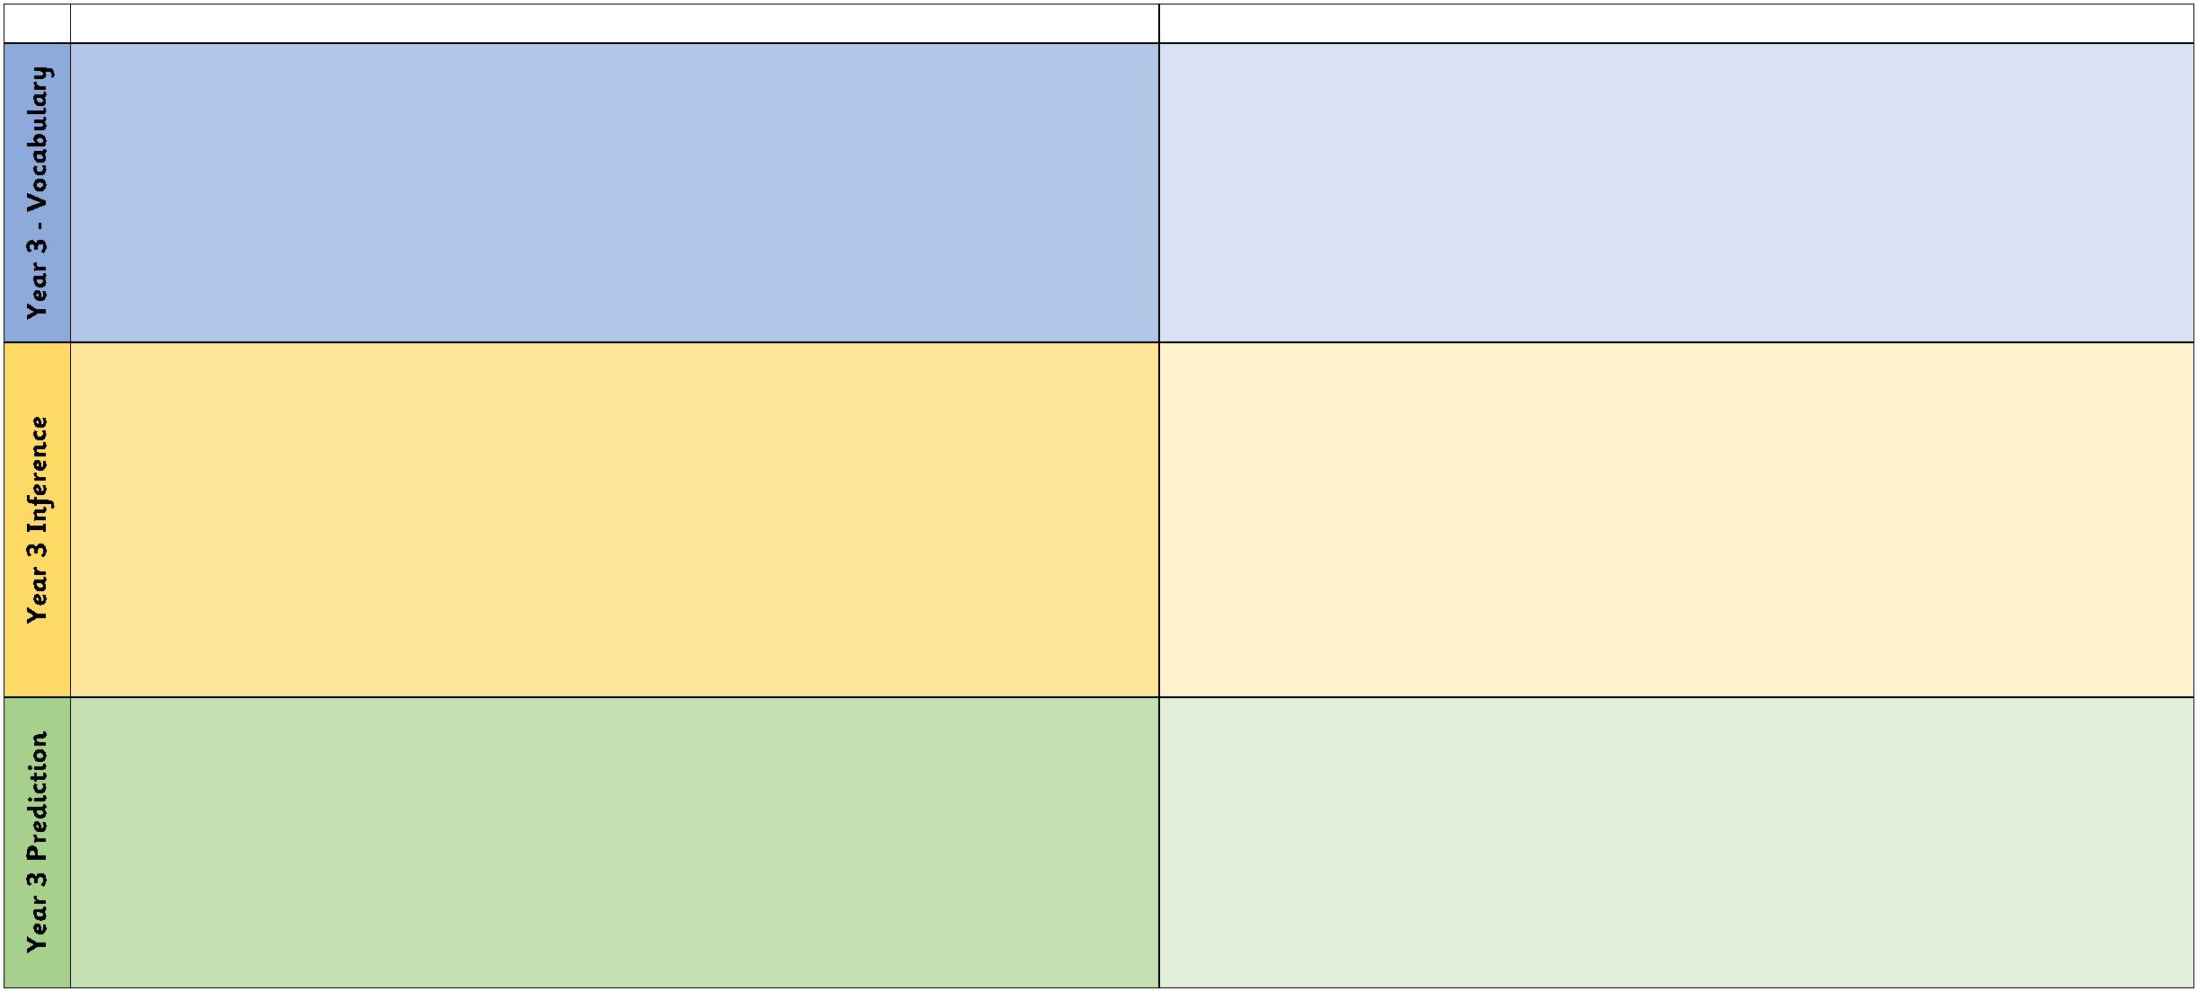

Year 3 VIPERS Progression Grid
E1.
E2.
E3.
discussing the features of a wide range of fiction, poetry, plays, non-fiction and
reference books
identifying how language, structure, and presentation contribute to meaning of both
fiction and non-fiction texts
recognise authorial choices and the purpose of these
•
•
•
•
•
•
•
•
•
What is similar/different about two characters?
Explain why... did that.
Describe different characters’ reactions to the same event.
Is this as good as...?
Which is better and why?
Why do you think they chose to order the text in this way?
What is the purpose of this text and who do you think it was written for?
What is the author’s viewpoint? How do you know?
How are these two sections in the text linked?
R1.
R2.
R3.
R4.
R5.
use contents page and subheadings to locate information
learn the skill of ‘skim and scan’ to retrieve details.
begin to use quotations from the text.
retrieve and record information from a fiction text.
retrieve information from a non-fiction text
•
•
•
•
•
•
•
•
•
•
•
•
•
•
Who are the characters in this text?
When / where is this story set? How do you know?
Which part of the story best describes the setting?
What do you think is happening here?
What might this mean?
How might I find the information quickly?
What can I use to help me navigate this book?
How would you describe the story?
Whose perspective is the story told from?
What is the main point in this paragraph?
Sum up what has happened so far in X words or less.
Which is the most important point in these paragraphs?
Do any sections/paragraphs deal with the same themes?
Have you noticed any similarities between this text and any others you have
read?
S1.
S2.
S3.
S4.
S5.
S6.
identifying main ideas drawn from a key paragraph or page and summarising these
begin to distinguish between the important and less important information in a text.
give a brief verbal summary of a story.
teachers begin to model how to record summary writing.
identify themes from a wide range of books
make simple notes from one source of writing
•
What do I need to jot down to remember what I have read?
